ANSI/SAIA A92.2 – 2021
American National Standard for

VEHICLE-MOUNTED ELEVATING and ROTATING AERIAL DEVICES

Date of Publication: August 15, 2021 Effective Date: August 2022

This Standard was approved by the American National Standards Institute on July 28, 2021

The design and manufacturing requirements of this standard apply to all aerial platforms manufactured on or after the effective date. All other provisions of this standard apply to both new and existing units delivered by sale, lease, rental or for any form of beneficial use on or after the effective date.

The effective date is established by the standards developer and not by the American National Standards Institute.

This standard was developed under procedures accredited as meeting the criteria for American National Standards. The Consensus Committee that approved the standard was balanced to ensure that individuals from competent and concerned interests have had an opportunity to participate. The proposed standard was made available for public review and comment which provides an opportunity for additional public input from industry, academia, regulatory agencies, and the public at large.

The Scaffold & Access Industry Association, Inc. (SAIA) does not “approve,” “rate,” or “endorse” any item, construction, proprietary device or activity.

The Scaffold & Access Industry Association, Inc. (SAIA) does not take any position with respect to the validity of any patent rights asserted in connection with any items mentioned in this document and does not undertake to ensure anyone utilizing a standard against liability for infringement of any applicable Letters Patent, nor does it assume any such liability. Users of this standard are expressly advised that the determination of the validity of any such patent rights, and the risk of the infringement of such rights, is entirely their own responsibility.

Participation by federal agency representative(s) or person(s) affiliated within the industry is not to be interpreted as government or industry endorsement of this standard.

The Scaffold & Access Industry Association, Inc. (SAIA) accepts responsibility for only those interpretations issued in accordance with governing ANSI Essential Requirements, which preclude the issuance of interpretations by individual volunteers.

ANSI/SAIA A92.2-2021

AMERICAN NATIONAL STANDARD for VEHICLE-MOUNTED ELEVATING and ROTATING AERIAL DEVICES

Secretariat

Scaffold & Access Industry Association, Inc.

Approved July 28, 2021

American National Standards Institute, Inc.

AMERICAN NATIONAL STANDARD
Approval of an American National Standard requires verification by ANSI that the requirements for due process, consensus, and other criteria for approval have been met by the standards developer.

Consensus is established when, in the judgment of the ANSI Board of Standards Review, substantial agreement has been reached by directly and materially affected interests. Substantial agreement means much more than a simple majority, but not necessarily unanimity. Consensus requires that all views and objections be considered and that a concerted effort be made toward their resolution.

The use of American National Standards is completely voluntary; their existence does not in any respect preclude anyone, whether he has approved the standard or not, from manufacturing, marketing, purchasing, or using products, or procedures not conforming to the standards.

The American National Standards Institute does not develop standards and will in no circumstances give an interpretation of any American National Standard. Moreover, no person shall have the right or authority to issue an interpretation of an American National Standard in the name of the American National Standards Institute. Requests for interpretations should be addressed to the secretariat or sponsor whose name appears on the title page of this standard.

CAUTION NOTICE: This American National Standard may be revised or withdrawn any time. The procedures of the American National Standards Institute require that action be taken to reaffirm, revise, or withdraw this standard no later than five years from the date of approval.
Purchasers of American National Standards may receive current information on all standards by calling or writing the American National Standards Institute.
Published by

Scaffold & Access Industry Association, Inc. 400 Admiral Boulevard
Kansas City, MO 64106 www.saiaonline.org

Copyright ©2021 by the Scaffold & Access Industry Association, Inc. All rights reserved.

No part of this publication may be reproduced in any form, in an electronic retrieval system or otherwise, without the prior written permission of the publisher.

Printed in the United States of America

FOREWORD
This foreword is not part of American National Standard for vehicle-mounted aerial devices, ANSI/SAIA A92.2-2021.

This standard is one of a series on aerial platforms developed under the committee procedures of the American National Standards Institute. The A92 standards committee was organized by the Institute in 1948. The Scaffold & Access Industry Association, Inc. serves as Secretariat.
The primary objective of this standard is to prevent accidents associated with the use of vehicle-mounted aerial devices by establishing requirements for design, manufacture, installation, maintenance, performance, use and training.

Interpretations and Suggestions for Improvement

All inquiries requesting interpretation of the Committee’s approved American National Standards must be in writing and directed to the Secretariat. The A92 Committee shall approve the interpretation before submission to the inquirer. Only the A92 Committee is authorized to provide any interpretation of this standard.

The A92 Committee solicits comments on and criticism of the requirements of the standards. The standards will be revised when necessary or desirable, as demonstrated by the experience gained from the application of the standards. Proposals for improvement of this standard are welcome. Proposals should be as specific as possible, citing the paragraph number(s), the proposed wording, and a detailed rationale for the proposal, including any pertinent documentation.

All requests for interpretation and all suggestions for improvement shall be forwarded in writing to the ASC A92 Committee, c/o Secretariat ~ Scaffold & Access Industry Association, 400 Admiral Boulevard, Kansas City, MO 64106.

This Standard was processed and approved for submittal to ANSI by Accredited Standards Committee Aerial Platforms, A92 Aerial Work Platforms. The ASC A92 committee’s approval of the standard does not necessarily imply that all committee members voted for its approval. At the time the ASC A92 committee approved this standard, the A92 Aerial Work Platforms Committee had the following members:

Joshua Chard, Ph.D., Chairman Frank Bonesteel, Vice-Chairman DeAnna Martin, Secretary

Alimak Group USA, Inc Gregory Janda
Tony Dragone Altec Industries Inc Bryan Hall
Robert Crowder Altec Neuco Butch Barron

Eric Lumberg American Rental Association John McClelland
Kevin Gern Arrowhead Aerial Products, Inc Sharon McCarty
Arrowhead Product Development, Inc Gary Werkhoven
Aspen Aerials, Inc Patrick Clark
Justin Laskowski Association of Equipment Manufacturers (AEM) Jeff Jurgens
Beta Max Inc Dave Reinert
Blazing Technologies Robert Backer
Bonesteel Construction Company Frank Bonesteel
BrandSafway Don Allen
Brent Hoover LLC Brent Hoover
Brewington & Company John Brewington
CED Technologies, Inc George Wharton
Century Elevators Paula Manning
CPWR The Center for Construction Research and Training Michael Kassman
Gary Gustafson Diversified Inspections/ ITL Jerry Tanner
Ralph Goodwin Duke Energy Carolina East David Benson
Sammy Nifong Duke Energy Florida Donald Barrows
Dur-A-Lift Inc Douglas Brinkhous
Eckstine and Associates, Inc Dennis Eckstine
Matthew Eckstine Elliott Equipment Company Alan Calta
Matt Gill Entergy Services, LLC Carey Stallings
EPRO Safety Solutions Albert Eccles
Eric A. Schmidt, P.E. Eric Schmidt
Evulich & Associates Barris Evulich
ExxonMobil Frank Radio
EZ Scaffold James Hinton
Florida Power and Light Company Glenn Martin
Fraco Products Ltd. Francois Villeneuve
Shanon Beekman GB MEWP Consulting, LLC. Carl Kishline
Genie Industries Jason Berry
Harrison Jenkins Global Rentals Joshua Chard, Ph.D.
Global Safety & Equipment Inc Geoffrey Arther
H&E Equipment Services, Inc Frankie Wynn
Haulotte Group Kevin Gildea, PE
Heath and Associates Frederick Heath
Helix Electric Christopher Hughes

Eric Simmons Herc Rentals Bill Cobb
Michael Hayden Jr. Hubbell Power Systems, Inc Dustin Sullivan
Hugg & Hall Equipment Bob Hendricks
Hy-Brid Lifts/ Custom Equipment Ben Froland
Hydro Mobile Inc Kevin O'Shea
Sony Trudel IBEW Local 164 Michael DeGiglio
International Masonry Institute (IMI) David Wysocki
IPAF, Ltd. Tony Groat
Dan Moss IREX Contracting Group Tom Pokornik
IVES Training & Compliance Group Inc Robert Vetter
JLG Industries Inc Mark Vaughn
Devin Mellott KHL Group/Access, Lift & Handlers Magazine Tony Radke
Klimer Platforms Inc James Gordon
Lee Electrical Construction Inc John Cook
Jason Lee Lewis Tree Service Chris Maka
Samuel Luna Lift-A-Loft Corporation Doug Jeurissen
McClain & Co., Inc Daniel McClain
MEC Aerial Work Platforms Gary Crook
Mark Kroeker MEWPs Inc Richard Staples
Scott Loura ML Cranes & Equipment Mickey Hodges
Moog USA Inc Martin Schweizer
Cindy Watson Niftylift Inc Steven Redding
James Clare OEM Controls, Inc Paul Rohaly
Robert Wuertz Palfinger North America, LLC Bobby Taylor
Will Urban Phenix Technologies Mark Miller
Pike Electric, LLC Andy Cleary
Kevin Watson Piranha Safety Eric Moran
Homer Kyle Power Equipment Leasing Co, Inc Tracy Schroeder
ReechCraft Inc Jason Solhjem
Shane Nickel Reynolds Engineering Services Inc Stephen Reynolds

RLH Consulting LLC Richard Hoffelmeyer
Salt River Project (SRP) Brendan King
Jason Kleiber Scaffold Resource, LLC Brett Friedel
SEA, LTD Brian Boggess
Skanska USA Building Spencer Hasenkopf
Skyjack Inc Ian McGregor
Snorkel International LLC Jeff Eckhardt, P.E.
Tony Deatherage Southern California Edison Randy Stone
Southern Company - Alabama Power Company Herman Scott
Jenny Taylor Sunbelt Rentals Brian Clark
Sunstate Equipment Co. Jake Kidd
Superior Scaffold Services Inc Shawn MacDonald
Technology International Co. Michael Zhou
Terex South Dakota, Inc Jim Olson
Dan Brenden Terex Utilities, Inc Nick Cammisa
David Sexton TESCO Equipment LLC Alan Wagamon
THD Rental Donald Satterfield
The Boeing Company Donald Dorfman
The Townsend Corporation Mark Kimbrough
The VON Corporation Fred von Herrmann
Martin von Herrmann Time Manufacturing Company James Christian
Brian Davis TNT Equipment Co. Michael Solomon
Tower Safety & Instruction Kathy Gill
TrainMOR / Morrison Industrial Equipment Scott Ahner
Tutus LLC Forrest Hester
Kevin Jones United Rentals Teresa Kee
Lee Braden Utility Truck Equipment & Parts LLC John Mlaker
Vollmer-Gray Engineering Paul Guthorn
Waco Boom Company Ltd Jonathan Woods
Bob Simon Wiss, Janney, Elstner Associates Inc Jason Kamman
Xtreme Manufacturing Jake Adkins
Jonathan Rasa Zachry Group Daniel Davis

Subcommittee A92.2 on Vehicle-Mounted Elevating and Rotating Aerial Devices, which developed this standard, had the following members:

Joshua Chard, Ph.D., Chairman Donald Allison, Ph.D., P.E. Ted Barron
Donald Barrows David Benson Robert Borer John Brewington Randall Breyer
Douglas Brinkhous Alan Calta
James Christian Andy Cleary John Cook
Alain Courchesne Brian Davis Michael DeGiglio Albert Eccles Matthew Eckstine Bryan Hall Mickey Hodges
Richard Hoffelmeyer Robert Hofmiller Christopher Hughes Jake Kidd
Brendan King Eric Lumberg

Sam Luna Chris Maka Glenn Martin
Sharon McCarty Mark Miller Robert Miller John Mlaker Jim Olson Justin Pilgrim
Stephen Reynolds Tracy Schroeder Herman Scott Bob Simon
Doug Simpson Matthew Skarshaug Michael Stiles Randy Stone Dustin Sullivan Jerry Tanner Bobby Taylor Jenny Taylor
Fred von Herrmann Gary Werkhoven Jonathan Woods

- Scope, Purpose, Requirements, and Application 1
  - Scope 1
    - Equipment Covered 1
    - Equipment Not Covered 1
  - Purpose 1
  - Requirements. 1
  - Application. 1
- Referenced and Related Standards 2
  - Referenced Standards 2
  - Related Standards 2
- Definitions 4
- Design Requirements 6
  - Basic Principles. 6
  - Structural Analysis 7
  - Controls. 7
    - General. 7
      - Visibility at Control Positions. 7
      - Unlocking or Enabling Device 7
    - Upper Controls 8
    - Lower Controls 8
    - Ground Travel Controls. 8
    - Emergency Stop. 8
    - Stabilizer Controls 8
    - Winch Control 8
    - Platform Level Adjustment 8
    - Automatic or Programmed Operation 8
    - Hydraulic Isolation/Selector Device 9
  - Securing Devices 9
    - Ladder Securing Device 9
    - Boom Securing Device 9
    - Platform Security 9
    - Locking Pins 9
  - Stability… 9
    - Stability on Level Surfaces. 9
    - Stability on Slopes. 9
    - Effects of Stability Test. 10
    - Slope Indicator 10
    - Stabilizer Interlock Device 10
    - Oscillating Axle Interlock Device 10
    - Manually Operated Stabilizers. 10
    - Parking Brake Interlock. 10
  - Hydraulic System 11
    - Bursting Safety Factors 11
    - Venting of Air 11
    - Resevoir Vent Filter 11
    - Fluid Level Indicators 11
    - Fluid Cleanliness 11
    - Gas-loaded Accumulators 11
    - Pressure Limiting Devices 11
  - Hydraulic Cylinders 11
    - Safety Factors. 11
    - Column Load. 11
    - External Load. 11
    - Threaded Components. 12
    - Hydraulic Pressure Rise. 12
  - Platform or Load Motion 12
    - System Protection 12
    - Platform Creep. 12
  - Platforms. 12
    - Guardrail System 12
    - Ladder Type 12
    - Folding Type Floors. 12
    - Anchorage(s) for Personal Fall Protection 13
      - Location 13
      - Markings 13
      - Strength Requirement. 13
      - Connector Requirement 13
      - Surface 13
    - Buckets or Baskets 13
      - Non-insulating buckets or baskets designed for use with insulating liners 13
      - Non-insulating buckets or baskets designed for use without liners 13
      - Insulating baskets or buckets. 13
      - Dimensions 13
  - Covers… 13
    - Aerial devices intended for gloving work methods 14
    - Cover Requirements 14
  - Material Handling Rope 14
  - Markings 14
    - Type of Markings 14
    - Design of Markings 14
- Electrical Systems, Devices and Test Procedures 14
  - Electrical Specifications 14
    - Insulation 14
    - Insulating Aerial Device Categories 14
  - Electrical Requirements 15
    - Insulating Systems 15
      - Insulating Hydraulic Hoses. 15
    - Partial Vacuum Limiting Systems 15
    - Lower Test Electrode System for Insulating Aerial Devices 15
      - Conductive Bands 16
      - Conductive Connections. 16
      - Electrical Monitoring Circuit 16
    - Gradient Control Devices & Conductive Shield(s) 16
      - Gradient Control Devices 16
      - Conductive Shield(s). 16
    - Chassis Insulating System 16
    - Upper Controls 17
  - Electrical Tests for Insulating Aerial Devices 17
    - Design Voltage Test. 17
    - Qualification Test 17
    - Periodic Electrical Test. 17
    - Before Use Test. 17
  - Electrical Test Procedures 17
    - General 18
    - Design and Qualification Test Procedures 18
      - Test Procedures for Category A & B Aerial Devices 18
      - Test Procedures for Category C, D and E Aerial Devices 18
      - Test Procedures for Aerial Ladders and Vertical Towers, with
Insulating Boom Sections 18
      - Test Procedures for Chassis Insulating Systems 19
      - Test Procedures for Insulating Liners 19
      - Confirmation Test of Upper Control Components with
High Electrical Resistance 19
      - Test Procedures for Extensible Boom Aerial Devices with
Permanent Electrodes 19
    - Periodic/Maintenance Test Procedures. 19
      - Test Procedures for Category A and B Insulating Aerial Devices 19
      - Test Procedures for Category C, D and E Aerial Devices 20
      - Test Procedures for Aerial Ladders and Vertical Towers with
Insulating Boom Sections 21
      - Test Procedures for Chassis Insulating Systems 21
      - Test Procedures for Insulating Liners 21
      - Test of Upper Control Components with High Electrical Resistance 21
      - Test Procedures for Extensible Boom Aerial Devices without Permanent Electrodes or with Electrodes and Tested as a Category C Device 22
  - Electrical Test Equipment. 22
  - Electrical Certification 22
    - Qualification Test 22
    - Periodic Electrical Test 22
    - Test Documentation 22
- Responsibilities of Manufacturers 22
  - General Responsibilities 22
  - Specifications 22
    - Vehicle Specifications 22
    - Aerial Device Specifications 23
      - General 23
      - Capacity 23
      - Multiple Configurations 23
      - Design Voltage 23
      - Qualification Voltage 23
  - Quality Assurance 24
  - Manuals 24
  - Markings. 24
    - Application of Markings 24
    - Identification Markings. 24
    - Operational Markings. 25
    - Instructional Markings 25
  - Mechanical Tests and Inspection. 25
    - Operational Tests 25
    - Visual Inspection. 26
  - Electrical Tests 26
  - Installation Instructions 26
  - Welding. 26
  - Training and Training Materials 26
- Responsibilities of Dealers and Installers 26
  - General Responsibilities 26
  - Vehicle Specifications 26
  - Vehicle Weight Distribution 26
  - Sale or Transfer of Equipment 26
    - Manuals 26
    - Transfer of Ownership 26
    - Notification of Owner/User Responsibilities 26
  - Installations. 27
    - Locking Pins. 27
    - Unauthorized Use 27
  - Ingress/Egress. 27
    - Steps/Ladders. 27
    - Access Opening/Passage 27
    - Three Point Support. 27
  - Quality Assurance 27
  - Weldings 27
  - Training. 28
    - Dealer, Installer or Service Entity as User. 28
  - Maintenance Training. 28
  - Service and Inspection Records 28
    - Service and Inspection Documentation 28
    - Periodic Inspection and Test Placard 28
    - Periodic Mandatory Component Replacement 28
- Responsibilities of Owners 28
  - General Responsibilities 28
  - Inspection and Testing Classifications 28
    - Initial Inspection and Test. 28
    - Regular Inspection and Tests 22
    - Frequent Inspection and Test: 28
    - Periodic Inspection or Test 29
    - Major Structural Inspection 30
    - Post Event Inspection or Test 30
  - Inspection and Test Records 31
    - Frequent 31
    - Periodic 31
  - Maintenance 31
    - Maintenance Training. 31
    - Welds. 31
  - Modifications. 31
    - Alterations. 31
    - Overriding Safety Devices. 31
  - Weight Distribution. 32
  - Transfer of Ownership 32
  - Markings 32
  - Parts 32
  - Safety Bulletins. 32
  - Manuals. 32
  - Training, Retraining, and Familiarization of Operators 32
    - General Training 32
    - Retraining. 33
    - Familiarization 33
  - Owner as a Lessor. 33
- Responsibilities of Users 33
  - General Responsibilities 33
  - Personnel. 33
  - Training, Retraining, and Familiarization of Operators 33
    - General Training: 33
    - Retraining 34
    - Familiarization 34
    - Proof of Training 34
    - Record Keeping 34
  - Application. 35
  - Electrical Hazards. 35
  - Bare-Hand Work. 35
  - Lower Controls. 35
  - Manufacturer’s Safety Bulletins. 35
- Responsibilities of Operators 35
  - General Responsibilities. 35
  - Personnel 35
  - Operation. 35
  - Work Platform. 35
  - Brakes. 36
  - Loading. 36
    - Vacating or Entering an Elevated Aerial Device 36
    - Carrying Materials Larger than the Platform. 36
  - Alterations 36
    - Overriding Safety Devices 36
  - Observations 36
    - Pre-start Inspection 36
    - Transporting 37
  - Worksite 37
  - Precautions 37
  - Mobile Operation 37
    - Driver Precautions 37
  - Training, Retraining, and Familiarization of Operators 38
    - General Training 38
    - Retraining. 38
    - Familiarization 38
  - Electrical Hazard 39
- Responsibilities of Lessors or Lessees 39
  - General Responsibilities 39
    - Lessor or Lessee as Dealer or Installer 39
    - Lessor or Lessee as Owner 39
    - Lessor or Lessee as User. 39
    - Lessor or Lessee as Operator 39
  - Ownership Responsibilities. 39
  - Obligations 39
    - Inspection and Test. 39
    - Responsibilities 39
  - Training. 39
    - General Training 39
    - Retraining 40
    - Familiarization 40
  - Communications. 40
  - Use of Brokers. 41
- Responsibilities of Brokers 41
  - Broker Involved In a Sale 41
  - Broker Involved In a Lease 41
TABLES
Table 1: Design, Quality Assurance and Qualification Test Values 42
Table 2: Periodic Electrical Test Values 45
Table 3: Before Use Tests 46
FIGURES
Figure 1: Dielectric Test Configuration for Category A & B Aerial Devices 47
Figure 1A: Details of Lower Test Electrode Assembly & Conductive Shield 48
Figure 2: Dielectric Test Configuration for Category C & DAerial Devices 49
Figure 2A: Optional Dielectric Test Configuration for Category C & DAerial Devices 50
Figure 3: Dielectric Test Configuration for Chassis Insulating Systems 51
Figure 3A: Suggested Shunting Arrangement for Chassis Insulating System 52
Figure 4: Boom Positions for Dielectric Test of Extensible Insulating Aerial Devices 53
Figure 5: Typical Bonding Arrangements for Category A Aerial Devices 54
Figure 6: Confirmation Test of Upper Control Components w/High Electrical Resistance 55
Figure 7: Recommended Identification Plate Format 56
APPENDICES
Appendix A: Electrical Test Terminology and Clarification 57
Appendix B: DC Application 57
Appendix C: Application and Uses of Aerial Devices 58
Appendix D: Electrical Tests for Aerial Devices, Insulated Platforms and
Insulated Ladders for AC Application 58
Appendix E: Electrical Tests for Aerial Devices Built in Compliance to
Earlier Editions of this Standard. 59
Appendix F: Precautions for Use of Aerial Devices on or near Energized Apparatus 60
Appendix G: Recommended Identification & Instruction Symbols for Control Function 64
Appendix H: Example Lower Test Electrode System Continuity Check Guide 70

Scope, Purpose, Requirements, and Application

Scope.

    - Equipment Covered. This standard relates to the following types of vehicle-mounted aerial devices:
- Extensible boom
- Aerial ladders.
- Articulating boom
- Vertical towers.
- A combination of any of the above. The vehicle may be a truck, a trailer, or an all-terrain vehicle.

    - Equipment Not Covered. This standard does not apply to the equipment listed below:
- Equipment such as that covered in ANSI/SAIA A92.20-2020 Design, Calculations, Safety Requirements and Test Methods for Mobile Elevating Work Platforms (MEWPs).
- Vehicle-mounted vertical lift devices such as those covered in American National Standard for Airline Ground Support Vehicle-Mounted Vertical Lift Devices, ANSI/SAIA A92.7-2014.
- Mast Climbing Work Platforms such as those covered in ANSI/SAIA A92.9-2011.
- Transport Platform such as those covered in ANSI/SAIA A92.10-2009 (R2014).
- Equipment such as that covered in ANSI/ASME A120.1- 2014 Safety Requirements for Powered Platforms for Building Maintenance.
- Vertically adjustable equipment used primarily to raise and lower materials and equipment from one elevation to another such as that covered in American National Standards in the A17 and B56 series.
- Fire-fighting equipment such as that covered in American National Standard for Automotive Fire Apparatus, ANSI/NFPA 1901-2016.
- Scaffolding such as that covered in American National Standard for Construction and Demolition Operations-Scaffolding Safety-Requirements ANSI/ASSP A10.8-2019.
- Construction and demolition operation digger derricks such as those covered in American National Standard for Construction and Demolition Operations - Safety Requirements, Definitions, and Specifications for Digger Derricks, ANSI/ASSP A10.31-2019.
- Personnel carrying attachments or personnel platforms attached to or suspended from cranes built to the ANSI/ASME B30 Standards. These excluded items are referred to in ANSI/ASME B30.23, which provides guidance for the use of such apparatus on cranes.
- Cranes; products primarily designed with a hoist to raise, lower and horizontally move a suspended load. Such equipment includes but is not limited to products designed to ASME B30 standards.
  - Purpose. This standard applies to the establishment of criteria for design, manufacture, testing, inspection, installation, maintenance, use, training, and operation of vehicle-mounted aerial devices, primarily used to position personnel, installed on a chassis to achieve the following objectives:
- Prevention of personal injuries and accidents.
- Uniformity in ratings.
- Understanding by manufacturers, dealers, brokers, installers, lessees, lessors, maintenance personnel, operators, owners, and users of their respective responsibilities.

  - Requirements. The requirements of this standard shall be met or exceeded.

  - Application. The design and manufacturing requirements of this standard apply to all aerial devices manufactured on or after the effective date. All other provisions of this standard apply to both new and existing units delivered by sale, lease, rental or by any other form of beneficial use on or after the effective date.

Referenced and Related Standards

Referenced Standards.
This standard is intended to be used in conjunction with the following standards. ANSI/IEEE C2-2017 Part 4, National Electrical Safety Code.
ANSI/ASSP Z359.1-2017, Safety Requirements for Personal Fall Arrest Systems, Subsystems and Components.

ANSI/NEMA Z535.1-2017, Safety Color Code. ANSI/NEMA Z535.3-2017, Criteria for Safety Symbols. ANSI/NEMA Z535.4-2017, Product Safety Signs and Labels.
ANSI/NFPA 505-2018, Fire Safety Standard for Powered Industrial Trucks Including Type Designations, Areas of Use, Conversions, Maintenance, and Operations.

AWS D1.1-2020, Structural Welding Code – Steel. AWS D1.2-2016, Structural Welding Code –Aluminum.
AWS B1.10-2016, Guide for the Non-Destructive Examination of Welds.

AWS D14.9/D14.9:2013, Specifications for the Welding of Hydraulic Cylinders

IEEE/ASTM SI 10-2016, Standard for Use of the International System of Units (SI): The Modern Metric System.

IEEE Std. 4-2013, Standard Techniques for High Voltage Testing.

IEEE Std. 516, Guide for Maintenance Methods on Energized Power Lines. IEEE 1307, Standard for Fall Protection for Utility Work.
Federal Motor Vehicle Safety Standards. SAE J517 Mar2017, Hydraulic Hose.

  - Related Standards. The standards listed here are for information only and are not essential for the completion of the requirements of this standard:

ANSI/SAIA A92.7-2014, Airline Ground Support Vehicle-Mounted Vertical Lift Devices. ANSI/SAIA A92.9-2011 (R2017), Mast-Climbing Work Platforms.
ANSI/SAIA A92.10-2009 (R2014), Transport Platforms.

ANSI/SAIA A92.20-2021, Design, Calculations, Safety Requirements and Test Methods for Mobile Elevating Work Platforms (MEWPs)

ANSI/SAIA A92.22-2021, Safe Use of Mobile Elevating Work Platforms (MEWPs)

ANSI/SAIA A92.24-2018, Training Requirements for the Use, Operation, Inspection, Testing and Maintenance of Mobile Elevating Work Platforms (MEWPs)

ANSI/ASME A120.1-2014, Safety Requirements for Powered Platforms for Building Maintenance. ANSI/ASSP A10.8-2019, Construction and Demolition Operations – Scaffolding – Safety Requirements.
ANSI/ASSP A10.31-2019, Construction and Demolition Operations – Safety Requirements, Definitions, and Specifications for Digger Derricks.

ANSI/ASME B30.5-2018, Mobile and Locomotive Cranes. ANSI/NFPA 1901-2016, Automotive Fire Apparatus.
ANSI/ISA Z133.1-2017 Tree Care Operations –Pruning, Trimming, Repairing, Maintaining, and Removing Trees, and Cutting Brush – Safety Requirements.

ASTM E114-2015, Ultrasonic Pulse-Echo Straight Beam Examination By Contact Method. ASTM E165-2018, Standard Test Method for Liquid Penetrant Examination.
ASTM E709-2015, Standard Guide for Magnetic Particle Examination.

ASTM F914-2018, Acoustic Emission Testing of Insulated and Non-Insulated Aerial Personnel Devices Without Supplemental Load Handling Attachments.

ASTM F1430-2018, Acoustic Emission Testing of Insulated and Non-Insulated Aerial Personnel Devices with Supplemental Load Handling Attachments.

CAN/CSA C225-20, Vehicle-Mount Aerial Devices.

SAE J343 Jan2017, Test and Test Procedures for AE 100R Series Hydraulic Hose and Hose Assemblies.

Definitions

Aerial Device. Any device, extensible, articulating, or both, which is primarily designed and used to position personnel. The device may also be used to handle material, if designed and equipped for that purpose.
Aerial Ladder. An aerial device consisting of a single or multiple-section rung ladder with or without a platform at the top.
Anchorage(s). A secure point of attachment to be used with personal fall protection (PFP) equipment.
Articulating-Boom Aerial Device. An aerial device with two or more hinged boom sections.
Authorized Personnel. A person(s) approved or assigned to perform a specific type of duty(s) or to be at a specific location(s) at the job site.
Bare-Hand Work. A technique of performing live line maintenance on energized conductors and equipment whereby one or more authorized persons work directly on an energized part after having been raised and bonded to the energized conductors or equipment.
Boom. The main structural components of an aerial device that support and elevate the platform and load. Broker. An independent business entity or person that arranges a lease or transfer of ownership of an aerial device, but is not the Lessor or does not make the actual transfer of ownership of the aerial device.
Certification. A written statement, signed by a qualified person, verifying that the design, manufacture, installation and testing of the aerial device is in accordance with this standard.
Chassis. A vehicle on which the aerial device is mounted such as a truck, a trailer, or an all-terrain vehicle. Chassis Insulating System. A system of non-conductive (insulating) components installed between the chassis and the structure supporting the upper boom. Such a system, when properly maintained, may provide insulation of the chassis should the portion of the aerial device between the boom and this system inadvertently contact an energized conductor or other apparatus.
Conductive Shield (Guard Ring). A device used to shield the lower test electrode system from capacitive coupling.
Dealer. A person or entity who buys (from a manufacturer or others) and who generally as a business sells, rents, leases, and/or services aerial devices.
Ductile Materials. Materials that have a minimum elongation at failure of 10% in a gauge length of 2 inches (51 mm) on a standard test specimen.
Equivalent Entity. An organization, agency, or individual who, by possession of an appropriate technical degree, certificate, professional standing, or skill, and who, by knowledge, training, and experience, has demonstrated the ability to deal with the problems relating to the subject matter, the work, or the project. Extensible-Boom Aerial Device. An aerial device, except the aerial ladder type, with a telescopic or extensible boom.
Familiarization. Showing the location of the operator’s manual and demonstrating the control functions, safety features, and specific operating characteristics of a particular model of aerial device to a trained operator.
Flashover. Passage of an arc following dielectric breakdown.
Gloving. A method of performing live work on energized electrical conductors and equipment where one or more workers, wearing specially made and tested insulating gloves, with or without sleeves, work directly on the energized electrical conductor or equipment. (See IEEE Std 516 Guide for Maintenance Methods on Energized Power Lines).
Guardrail System. A vertical barrier intended to protect personnel from falling to lower levels.
Gradient Control Device. A device(s) at the upper end of an insulating boom that reduces electrical stress

level(s) below that considered to be disruptive (commonly referred to as a “corona ring”).
Hazardous Location. Any location that contains, or has the potential to contain, an explosive or flammable atmosphere as defined in ANSI/NFPA 505.
Instability. A condition of a mobile unit (MEWP) in which the sum of the moments tending to overturn the unit is equal to or exceeds the sum of the moments tending to resist overturning.
Installer. A person(s) or entity who mounts an aerial device on a vehicle.
Insulated. Separated from other conducting surfaces by a dielectric substance or air space offering a high resistance to the passage of electrical current and to disruptive discharge through the substance or space. When any object is said to be insulated, it is understood to be insulated in a manner suitable for the conditions to which it is subjected.
Insulating Aerial Device. An aerial device with dielectric components designed and tested to meet the specific electrical insulating rating consistent with the manufacturer’s identification plate.

Insulating Components (non-conductive).
Components that are composed of materials selected for their electrical resistance.
Insulating Liner. An insert made of non-conductive (insulating) material and designed to fit inside the platform.
Lessee. A person(s) or entity to whom an aerial device is provided by lease, rental, loan, or other arrangement. A lessee may also be a dealer, user, or operator.
Lessor. A person(s) or entity who leases, rents, loans, or otherwise provides an aerial device to another party for the beneficial use of that party (the lessee). A lessor may also be a dealer, installer, manufacturer, owner, lessee, user, or operator.
Manual Force. The load produced by person(s) in the platform working on a stationary object, external to the aerial device. These loads are generally horizontal in nature and are applied at the upper periphery of the platform.
Manufacturer. A person or entity who makes, builds, or produces an aerial device.
Minimum Approach Distance (MAD). The closest distance a qualified person is permitted to approach either an energized or a grounded object, as applicable for the work method being used.
Mobile Operation. The uncradled use of the aerial device while the mobile unit (MEWP) is traveling. Mobile Unit (MEWP). A combination of an aerial device, its chassis, and related equipment. Mobile unit (MEWP) is equivalent to the term Mobile Elevating Work Platform.
Non-Destructive Examination (NDE). The examination by various means of devices or their components without alteration of the original components, so that they may function as before. These include, but are not limited to, visual inspection (VT), acoustic emissions (AE), magnetic particle (MT), liquid penetration (PT), ultrasonic (UT), and dielectric (DT).
Non-Ductile Materials. Materials that have an elongation at failure of less than 10% in a gauge length of 2 inches (51 mm) on a standard test specimen.
Operator. A person trained, authorized, and engaged in the operation of the aerial device.
Override. The takeover of aerial device movement and winch control functions at the platform controls by the activation of the lower control station controls.
Owner. A person or entity who has possession of an aerial device by virtue of proof of purchase. Platform. The personnel-carrying component of an aerial device, such as a bucket, basket, stand, or equivalent.
Platform Capacity. The component of rated load capacity consisting of the weight of personnel and all items carried on or in the platform, including the liner.
Platform Height. The distance measured at maximum elevation from the bottom of the platform to the ground.
Platform Reach. The distance measured horizontally from the centerline of the pedestal (rotation) to the

outer edge (rail) of the platform.
Qualified Person. A person who, by possession of an appropriate technical degree, certificate, professional standing, or skill, and who, by knowledge, training, and experience, has demonstrated the ability to deal with problems relating to the subject matter, the work, or the project.
Rated Load Capacity (Platform Capacity + Supplemental Capacity). The maximum loads, specified by the manufacturer, which can be lifted by the aerial device through the specified range of boom elevation and extension with specified options installed and in consideration of stability requirements. Unless oth-erwise specified, these loads are vertical.
Rated Platform Height. The distance measured at maximum elevation from the bottom of the platform to the ground based on a chassis height of 40 inches (1 meter).
Safety-Related Bulletin. Publication from the manufacturer or installer of the aerial device and or mobile unit (MEWP) that requires the attention of those in control of an aerial device to assure its safe operation. Service Entities. A person or entity whose business is inspecting, testing, performing maintenance and/or repair on an aerial device or MEWP.
Shall. The use of the word “shall” is to be understood as mandatory, and having the same effect as “must” and “will.”
Should. The use of the word “should” is to be understood as advisory, and having the same effect as “recommended.”
Stabilizer. Any device or system used to stabilize a (MEWP) by supporting and/or leveling it.
Stability. A condition of a mobile unit (MEWP) in which the sum of the moments which tend to overturn the unit is less than the sum of the moments tending to resist overturning.
Stowed Position (of the Boom). The position of the boom on the vehicle where it is intended for non-use and/or transport.
Supplemental Capacity. The component of rated load capacity which may be fixed directly to the boom(s), or to load carrying attachments on the aerial device.
Telescopic Aerial Device. See extensible-boom aerial device.
Trainer. A qualified person who conducts the training of an aerial device/mobile unit (MEWP) operator or service personnel.
Training. Instruction to enable the trainee to become a qualified person regarding the task to be performed, including knowledge regarding potential hazards.
Test Electrode System The components installed on the aerial device that enable current monitoring across the insulating section.
User. A person(s) or entity who has care, control and custody of the aerial device. This person(s) or entity may also be the employer of the operator, a dealer, an installer, lessee, lessor, or operator.
Vehicle. A carrier for an aerial device (see chassis).
Vertical Tower. Any aerial device with a platform which can be raised along a vertical axis.

Voltage.
Rated Line Voltage: The nominal phase to phase voltage at which electrical systems are rated.
Design Voltage: The maximum rated line voltage for which the aerial device has been designed, and for which it can be qualified.
Qualification Voltage: The rated line voltage for which the aerial device has been actually tested.

Design Requirements
  - Basic Principles. The design and manufacture of the aerial device shall comply with the principles outlined in this standard. Sound engineering principles and reasonable assumptions consistent with all data regarding intended use and anticipated environment shall be applied in the design of aerial devices, with

due respect to the fact that the units carry personnel.

  - Structural Analysis. Structural elements of the aerial device which support the platform, the platform itself, and material carrying attachments, if so equipped, shall have a design stress as stated herein. The calculated design stress shall be based on the combined rated load capacity and weight of the support structure.

For ductile material(s), the design stress shall not be more than 50% of minimum yield strength of the material or more than 50% of the elastic column strength of the material for members in compression.

For non-ductile material(s) and fiberglass reinforced plastic, the design stress shall not be more than 20% of the minimum ultimate strength of the material.

For chains, wire rope assemblies, and components rated according to ultimate strengths, the design loads shall not be more than 20% of the ultimate strength.

Some components that have been qualified by test and or acceptable design criteria shall be considered as providing equivalent levels of safety in accordance with this section. Examples include gears, gear boxes, threaded fasteners, and bearings. For these components, the original manufacturer’s ratings shall not be exceeded.

The analysis shall consider the effects of the following:
- Stress concentrations
- Dynamic loadings
- Operation on a minimum of 5degrees slope but up to the manufacturer’s allowable slope(s).
- Operation of aerial device at maximum slope allowed by manufacture
- Ambient temperatures for which the aerial device has been designed.
- Loads produced during travel and mobile operations.
- Loads produced from wind.
- Loads produced from manual forces applied at the upper periphery of the platform (Minimum value shall be 50 pounds applied horizontally for aerial devices designed to carry one person and 100 pounds applied horizontally for aerial devices designed to carry more than one person.)
- Loads that produce column (compressive) loading
- Fatigue-stress during normal operation and transport.

Controls

    - General. Aerial devices shall have both upper and lower controls for boom positioning. All controls shall be clearly identified as to their function and protected from damage and unintentional actuation. The boom positioning and material carrying attachment controls shall return to their neutral position when released by the operator.

Visibility at Control Positions
Any control position shall allow the operator to see the resulting movements.

      - Unlocking or Enabling Device. The use of an unlocking or enabling device shall precede the use

of boom and platform positioning controls. The unlocking or enabling device may be incorporated into each control. A separate control that has to be continuously activated by the operator in order for any motion to take place meets this requirement. Foot controls, if so equipped, shall have slip-resistant surfaces and be easy to clean. The unlocking or enabling device shall return to the locked or disabled position when the control is released by the operator.

    - Upper Controls. Upper controls shall be in or beside the platform and readily accessible to the operator. On a two-platform aerial device, control operation from either platform shall be accomplished with reasonable ease and without the need to disengage personal fall protection equipment.

    - Lower Controls. Lower controls shall be readily accessible in all boom positions and shall provide a means to override the boom positioning upper controls provided the upper control system is intact. The override mode shall maintain its function while unattended. The lower controls of insulating aerial devices shall be designed in such a manner that an operator is not placed in the electrical path between the aerial device and the ground.

    - Ground Travel Controls Travel controls fixed to a mobile unit (MEWP) and operated from the ground in front or behind the unit shall be positioned so as to cause the operator to stand at least 36 in. from the vertical tangent of the wheels or crawlers. These travel controls shall return to neutral when released and engage the holding brake.

    - Emergency Stop. An additional control shall be provided at each boom positioning control station(s) to affect an emergency stop of the powered upper control functions. These controls shall be permanently marked 2and shall not require continuous actuation for a stop condition. At the lower controls, the override control may be used as an emergency stop, provided it is clearly identified as an “emergency stop.”

    - Stabilizer Controls. When the aerial device is equipped with stabilizer controls, these controls shall be guarded to protect against unintentional operation and shall return to neutral when released by the operator.

For outrigger type stabilizer(s), the controls shall be located so that the operator can see the outrigger type stabilizer(s) being operated.

    - Winch Control. If the aerial device is equipped with a material handling winch at the upper boom, it shall have both upper and lower controls to operate the winch. The lower control shall provide for overriding the upper control provided the upper control system is intact. The lower winch control shall be accessible from the lower boom positioning controls.

Platform Level Control.

      - During Operation. After the initial leveling (either manual or automatic) of the platform, the level of the work platform shall not vary by more than 5 degrees from the initial setting when the boom structure is raised or lowered. Initial level setting is considered reset after platform leveling adjustment.

      - Manual Operation. Manually controlled adjustment of the level of the platform is permissible in all positions of the work platform. From upper controls the rate of change of the platform angle shall not exceed the maximum that occurs during the boom lowering or raising operation.

    - Automatic or Programmed Operation. Automatic or programmed operation performed with the primary function joystick, lever, or switch released is permissible provided a separate control is continuously activated and release interrupts the movement. The use of an unlocking or enabling device shall precede the use of the control itself.

    - Hydraulic Isolation/Selector Device. A device shall be provided that prevents simultaneous operation of aerial device hydraulic powered functions and hydraulically powered stabilizers and other components that would detrimentally affect aerial device operation. Manually operated devices shall remain in the bypass mode selected by the operator. Automatic devices shall be effective when the boom is out of the stowed position. An override may be provided on automatic devices; however, the override mode of operation shall disable automatically.

Securing Devices

    - Ladder Securing Device. Aerial ladders that are counterbalanced for ease in raising to, and lowering from, an operating position shall be equipped with a device to secure the ladder in the traveling position.

    - Boom Securing Device. Aerial devices shall be equipped either with a device(s) to secure the boom(s) or shall be designed to ensure that the boom(s) remain in the cradled position when in transport.

    - Platform Security. Platforms shall be designed to withstand vibration and shock loading during travel.

    - Locking Pins. Removable locking pins shall have a means to be secured against unintentional disengagement and loss.

Stability

    - Stability on Level Surfaces. Each aerial device, when mounted on a vehicle meeting the manufacturer’s minimum vehicle specifications, without readily removable tools and material and used in a specific configuration, shall comprise a mobile unit (MEWP) capable of sustaining a static load one and one-half times its rated load capacity, in every position in which the load can be placed within the definition of the specific configuration, when the vehicle is on a firm and level surface.

The load shall be applied at one and one-half times the platform capacity at the center of the platform simultaneously with one and one-half times the lifting attachment supplemental capacity in its position of maximum overturning moment when so equipped.

Simultaneous application of platform capacity and supplemental capacity shall be performed only on aerial devices that are designed for use with both types of load applied simultaneously. If having outriggers or other stabilizing components utilized is part of the definition of the configuration, they shall be so utilized according to the manufacturer’s instructions for purposes of determining whether the mobile unit (MEWP) meets the stability requirements.

    - Stability on Slopes. Each aerial device, when mounted on a vehicle meeting the manufacturer’s minimum vehicle specifications without readily removable tools and material and used in a specific

configuration, shall comprise a mobile unit (MEWP) capable of sustaining a static load one and one-third times its rated load capacity in every position in which the load can be placed within the definition of the specific configuration when the vehicle is on a slope of 5 degrees in the direction of least stability. The slope of the aerial device shall be at the maximum allowed slope by the manufacture in the direction of least stability. If the allowable limits of the unit exceed a 5-degree slope, this test shall be conducted on the allowable limit slope(s). The load shall be applied at one and one-third times the platform capacity at the center of the platform simultaneously with one and one third times the lifting attachment supplemental capacity in its position of maximum overturning moment when so equipped.
If having outriggers or other stabilizing components utilized is part of the definition of the configuration, they shall be utilized according to the manufacturer’s instructions for purposes of determining whether the mobile unit (MEWP) meets the stability requirements.

Simultaneous application of platform capacity and supplemental capacity shall be performed only on aerial devices that are designed for use with both types of loads applied simultaneously.

    - Effects of Stability Test. None of the stability tests described in 4.5.1 and 4.5.2 shall produce instability of the mobile unit (MEWP) or cause permanent deformation of any component.

Note: During the stability test, the lifting of a tire(s) or outrigger type stabilizer(s) on the opposite side of the load does not necessarily indicate a condition of instability.

    - Slope Indicator. An indicator(s) shall be provided that is visible to the operator during set up to show whether the aerial device is positioned within limits permitted by the manufacturer. The allowable limits shall be shown on the unit and in the manual. For units designed for mobile operation, such an indicator(s) shall be supplied in the cab.

    - Stabilizer Interlock Device. When an aerial device is equipped with stabilizers, and their use is required to pass the stability tests of this standard, an interlock device shall be provided that prevents the boom from being operated from the stowed position until the stabilizers have been deployed. For outrigger type stabilizers, deployment may be sensed when the outriggers meet resistance or by receipt of an indicative response that the outrigger deployment is beyond a predetermined position. An interlock override switch may be provided; however, the override mode of operation shall disable automatically prior to the next mobile unit (MEWP) set up.

Note: The operation of a stabilizer interlocking device(s) does not ensure aerial device stability. It serves only to remind the operator that the stabilizers have not been deployed. See Section 10.10 (4).

    - Oscillating Axle Interlock Device. When a mobile unit (MEWP) is equipped with oscillating axle locks or control systems, and their use is required to pass the stability tests of this standard, an interlock device shall be provided that prevents the boom from being operated from the stowed position until oscillation of the axle(s) is locked or controlled.

    - Manually Operated Stabilizers. Manually operated stabilizers shall be designed to prevent unintentional movement of the stabilizer.

    - Parking Brake Interlock. For aerial devices not designed for mobile use that are equipped with a parking/holding brake, an interlock device shall be provided that prevents operation of the aerial device

until the parking/holding brake has been set.

Hydraulic System

    - Bursting Safety Factors. All hydraulic components whose failure could result in motion of the platform(s) or material lifting device or both shall have a minimum bursting strength of at least four times the maximum operating pressure for which the system is designed.

All other hydraulic components normally rated according to bursting strength, such as hose, tubing, and fittings, shall have a minimum bursting strength of at least three times the operating pressure for which the system is designed. All other hydraulic components normally rated according to performance criteria, such as rated flow and pressure, life cycles, pressure drop, rpm, torque, and speed, shall have a minimum bursting strength of at least two times the maximum operating pressure for which the system is designed. Such components generally include pumps, motors, directional controls, and similar functional components.
    - Venting of Air. The design of the hydraulic system shall allow entrapped air to be vented if required for proper operation.

    - Reservoir Vent Filter. Any fluid reservoir vent shall be equipped with a filter.

    - Fluid Level Indicators. Hydraulic reservoirs for the aerial device shall be equipped with a device to indicate the permissible liquid levels when the MEWP is in the stowed position.

    - Fluid Cleanliness. Each hydraulic system shall have means to maintain the fluid cleanliness level necessary for operation of the system and its components. The manufacturer shall provide instructions for proper maintenance.

    - Gas-Loaded Accumulators. In hydraulic systems incorporating gas-loaded accumulators, a means shall be provided to vent the liquid pressure automatically or to positively isolate the accumulator when the system is in the unpressurized state.
If the gas-loaded accumulator pressure is required by design to be retained when the system is shut off, complete information for safe servicing shall be given on or near the accumulator in a visible location. Duplicate information shall be provided in the maintenance manual.

    - Pressure Limiting Device. The hydraulic system shall include a pressure limiting device, such as a pressure relief valve before the first control valve. The adjustment of the pressure limiting device shall require the use of tools and shall be capable of being sealed.

Hydraulic Cylinders

    - Safety Factors. Cylinder components subjected to hydraulic pressure shall comply with the requirements of Section 4.6. All other components of the cylinder shall comply with Section 4.2.
    - Column Load. The maximum load on any cylinder at the rated load capacity of the aerial device in any position shall not exceed one half of the load which would cause permanent deformation.

    - External Load. Stresses calculated for load carrying components shall include the additive effects of both external and internal forces, such as those resulting from hydraulic pressure.

    - Threaded Components. All threaded members used to secure critical components such as hydraulic pistons, barrel bases, head glands, and rod eyes, shall be secured against rotation by means of a suitable locking device.

    - Hydraulic Pressure Rise. A means shall be provided to limit pressure rise due to factors such as thermal expansion of hydraulic fluid and leakage that could result in stresses that exceed the yield strength of the material.

Platform or Load Motion

    - System Protection. The system shall be designed to prevent motion in the event of power loss. Where the operation of the aerial device is accomplished by hydraulic means, the system shall be equipped with appropriate devices to prevent motion of the platform(s) or material lifting device, or both, in the event of hydraulic line failure.
This requirement does not apply to properly guarded metallic tubing installed between a holding device and the cylinder.

    - Platform Creep. Aerial devices shall be capable of successfully passing the following test to measure platform creep. An aerial device being tested shall be loaded to its rated load capacity and placed in the position where the platform creep vs. the motion of all the cylinders supporting the platform will be maximized. The oil within the cylinders shall be allowed to equalize with the ambient temperature prior to the test. The allowable platform creep in any direction shall not exceed 4 inches (100 mm) in one hour plus an additional 1/2 inch (13 mm) per hour for every 10 feet in unit height over 60 feet, up to a maximum of 12 inches (305 mm).

Platforms

    - Guardrail System. Platforms other than buckets or baskets shall include a guardrail system:
- The guardrail system shall include a top rail around its upper periphery. The top rail shall be 42 inches (1067 mm) high, plus or minus 3 inches (76 mm) above the platform surface, designed to withstand 300 pounds of force (1335 N) in any direction without ultimate failure.
- The guardrail system shall include at least one rail approximately midway between the top rail and the platform surface, designed to withstand 300 pounds of force (1335 N) in any direction without ultimate failure.
- The platform shall include toeboards on all sides. The minimum toeboard height shall be 4 inches (102 mm). Toeboards may be omitted at the access opening.
- The configuration of the aerial platform shall include access for personnel entering the platform when it is in the lowered position or stowed. Access steps or rungs shall have a slip resistant surface. Flexible materials such as cables, chains, or rope may be used across access opening(s) not more than 30 inches (762 mm) wide.

    - Ladder Type. Ladder type platforms are permissible.

    - Folding Type Floors. Platforms with folding type floors and steps or rungs may be used without rails

and toeboards.

Anchorage(s) for Personal Fall Protection

      - Location. The manufacturer shall provide anchorage(s) on the boom, platform, or platform mounting. The anchorage shall be designed to protect against detrimental interference between components of the aerial device having movement relative to the anchorage and an attached lanyard connector.

      - Markings. Location of the anchorage(s) shall be identified, and the number of anchorages shall equal or exceed the number of permissible occupants. More than one occupant may attach to a single anchorage if the anchorage is rated and identified as being for more than one person.

      - Strength Requirement. Anchorages shall be capable of withstanding a static force of 3600 lbs. (16,000 N) for each person allowed by the manufacturer on the attachment without reaching ultimate strength. The strength requirement shall apply only to the anchorage(s) and their attachments to the boom, platform, or platform mounting.

Note: This does not imply that the aerial device is meant to meet or comply with this load requirement.

      - Connector Requirement. Anchorage shall be compatible with a lanyard connector complying with ANSI/ASSP Z359.1-2017.

      - Surface. Anchorage(s) surfaces shall be free from sharp edges.

Note: See Sections 8.12.1, 9.3.1, 10.12.1 and 11.4.1 for more information pertaining to proper use of personal fall protection equipment.

Buckets or Baskets.

Non-Insulating Buckets or Baskets Designed for Use with Insulating Liners.
These non-insulating baskets shall be constructed from non-conductive materials or when installed, be capable of complying with Section 4.10 Covers. The basket shall be identified as non-insulating. Insulating liners for these baskets shall be constructed from non-conductive materials and tested in accordance with Section 5.4.2.5. The liner shall be supported by the inside bottom surface of the basket. These non-insulating baskets shall not have drain holes or access openings.

      - Non-Insulating Buckets or Baskets Designed for Use Without Liners. These non-insulating baskets may be constructed from conductive or non-conductive materials. The basket shall be identified as non-insulating. These non-insulating baskets may have drain holes and/or access openings.

      - Insulating Baskets or Buckets. Insulating baskets shall be constructed from non-conductive materials and shall have no drain holes or access openings. Insulating baskets shall be tested in accordance with the dielectric tests for liners Section 5.4.2.5.

      - Dimensions. Work platforms shall have a depth of 42 inches (1067 mm) plus or minus 3 inches (76 mm) from the standing surface to the top of the platform.

Covers

    - Aerial Devices Intended for Gloving Work Methods. Aerial devices intended for gloving work methods shall have covers for metal boom tip components of the aerial device that are exposed to conductor contact and are at risk of phase to ground or phase to phase current flow.

    - Cover Requirements Covers shall be designed so that:
- They are constructed of high electrical resistance material.
- They are resistant to absorption of moisture and the effects of environmental degradation.
- Pre-start inspection(s) can be performed without removal of covers.

  - Material Handling Ropes. For synthetic-type rope(s), the average breaking strength shall not be less than 5 times the maximum working load.

Markings
    - Type of Markings. An aerial device shall have the following markings:
- Identification markings
- Operational markings
- Instructional markings

    - Design of Markings. Color, format and substance shall conform to the following Standards: ANSI/NEMA Z535.1-2017, Safety Color Code, ANSI/NEMA Z535.3-2017, Criteria for Safety Symbols and ANSI/NEMA Z535.4-2017, Product Safety Signs and Labels.

Electrical Systems, Devices and Test Procedures

Electrical Specifications

    - Insulation. The aerial device manufacturer shall state in the manual and on the instruction plate(s) whether the aerial device is insulating or non-insulating.
Note: Insulating aerial devices do not protect personnel from phase to phase or phase to ground contacts at the platform end.

Insulating Aerial Device Categories

- Category A.
  - Aerial devices which are designed and manufactured for bare-hand work in which the boom is the primary insulation. All conductive components at the platform end shall be bonded together to accomplish equipotential of all such components (Figure 5). Such aerial devices shall be marked at the platform indicating such bonding. These aerial devices shall be equipped with a lower test electrode system (Figure 1A). When these aerial devices are qualified for work above 138 kV, they shall be equipped with a gradient control device and conductive shield(s) over the lower test electrode system. For those aerial devices with ratings 138 kV and below, conductive shield(s) over the lower test electrode system are required. The necessity of a gradient control device shall be determined by the Qualification test. In all other configurations, the boom is not considered as primary insulation but secondary.

  - Category A units may be designed and configured for gloving work provided they meet the requirements of Section 4.10.

Category B.
  - Aerial devices which are equipped with a lower test electrode system (Figure 1A) but are designed and manufactured for work in which the boom is not considered as primary insulation, but secondary to using insulating tools. Category B aerial devices require the use of live line tools with appropriate dielectric ratings. These tools are to be depended upon for primary protection, just as in all cases where the boom is used as secondary protection.
  - Category B units may be designed and configured for gloving work provided they meet the requirements of Section 4.10.

- Category C. Aerial devices which are not typically equipped with a lower test electrode system and are designed and manufactured for work in which the insulating system is not considered as primary insulation, but secondary to, using insulating gloves or tools. These aerial devices are designed for gloving work and tool methods at voltages of 46kV and below. They shall meet the requirements of Section 4.10

- Category D. Aerial devices which are designed and manufactured for work in which the insulating system is not considered as primary insulation, but secondary. They do not need to meet the requirements of Section 4.10, as these aerial devices are NOT designed for gloving work methods. They are rated at voltages of 46kV and below.

- Category E. Aerial devices which are designed for lower voltage applications. Insulation requirements of the standard may be accomplished through guarding or isolation methods. These units are designed and manufactured for work in which the unit is not considered as primary insulation, but secondary. They are rated at voltages of 20kV, 5kV, and 1kV and below.

Electrical Requirements

    - Insulating Systems. The insulating portions of the aerial device shall be identified in the manual and on the aerial device. All components crossing the insulating portions of the aerial device shall have electrical insulating values consistent with the design voltage rating of the boom, and when provided, of the chassis insulating system. The insulating system shall maintain the electrical insulating values in all working boom positions as defined by the manufacturer.

      - Insulating Hydraulic Hoses. All hydraulic hoses crossing the insulating sections of the aerial device shall meet the insulating requirements of SAE J517.

    - Partial Vacuum Limiting Systems. Category A & B aerial devices with insulating hydraulic lines which cross the insulating portions shall have a method to limit vacuum formation in such lines and resulting reduction in dielectric strength. The system shall be designed to limit the partial vacuum to be no more than 75% of atmospheric pressure. Suitable access to the vacuum limiting components for testing and service shall be provided.

    - Lower Test Electrode System for Insulating Aerial Devices. A system to enable electrical current monitoring shall meet the following requirements.

Note: Details of a typical system are shown in Figure 1A.

      - Conductive Bands. Conductive bands shall be installed permanently on the inside and outside surfaces of the insulating portion of the upper boom. The conductive bands shall be 2 inches minimum (approximately 50 mm) from the metal portion of the lower end of the insulating boom.

      - Conductive Connections. All hydraulic and pneumatic lines crossing the insulating portion of the upper boom shall have conductive couplings at a common point, which can be at a bulkhead, which connect the inside and outside of each line to the current monitoring circuit. All fiber optic lines crossing the insulating portion of the upper boom shall have conductive couplings at the common point (bulkhead) to enable connection of the inside and outside of each line to the current monitoring circuit. On fiber optic lines certified by test to be dielectrically sound and to not wick water, the coupling may be connected to the outer sheathing only. All other components that cross the insulating section of the upper boom, such as leveling rods, shall connect to the common point (bulkhead) that enables electrical current monitoring.

      - Electrical Monitoring Circuit. The conductive bands, fiber optic cable(s), hydraulic and pneumatic line(s), and any other item(s), such as leveling rods, shall be electrically connected individually at the common point (bulkhead) and monitored from a common pickup point. Provisions shall be made for the isolation of individual components to identify each leakage path. A shielded lead(s) to provide an electrical monitoring path shall be routed to a meter receptacle located on either the upper or lower boom, below the common point (bulkhead). There shall be separation between the shielded lead(s) and hydraulic lines, or suitable means of heat shielding for hydraulic lines, or conductive shield(s) over the lower test electrode system. Suitable access shall be provided to the common point (bulkhead) and to the electrical connections inside the boom.

Gradient Control Devices & Conductive Shield(s)

      - Gradient Control Devices. Gradient control device(s), when required, shall be:
- Installed on the platform end of the insulating section of the upper boom; all conductive items, including fittings at the platform, shall be bonded to the gradient control device, and no conductive component may extend past the device(s) in any boom position.
- Designed to prohibit installation in an orientation not intended by the manufacturer or shall be permanently marked to identify the manufacturer's intended orientation.
Note: During the ac design voltage test, the gradient control device shall not permit corona streamers to impinge on the insulating system.
      - Conductive Shield(s). Insulating aerial devices equipped with gradient control devices shall have the lower test electrode system equipped with a conductive shield (Figure 1A) or an equivalent to reduce the capacitive coupling effect and to improve indication of resistive current.

    - Chassis Insulating System. All Category C & D articulated aerial devices with a conductive articulating boom structure below the insulating upper boom but above rotation shall have a chassis insulating system.

The chassis insulating system may provide some protection for ground personnel should the portion of the aerial device between the upper insulating boom and the chassis insulating system inadvertently contact an energized conductor or apparatus such as a secondary circuit on a distribution system. When provided, the chassis insulating system does not have a voltage rating. Category A & B aerial devices with a chassis insulating system shall have means provided to bypass the chassis insulating system for bare-hand use (Figure 3A).

Note: Insulating devices when used for bare-hand work (Category A) require shunting of an existing chassis insulating system.

    - Upper Controls. The upper control conductive components are bonded together on Category A machines, but such bonding is optional on Category B and Category C machines. Categories B, C, and D machines may incorporate control systems with high electrical resistance components. Machines that incorporate components for their electrical resistance shall receive an initial confirmation test and be subjected to the requirements for periodic inspections (see Sections 5.4.2.6, 5.4.3.6). Controls that employ high electrical resistance components do not have a voltage rating and are not part of the insulating system that enables an aerial device to have an insulating rating. Controls that employ high electrical resistance components shall be identified. Specific warnings and advice shall be provided to the operator(s) that the upper controls do not provide protection in the event of electrical contact and are not a substitute for Minimum Approach Distances, cover-ups, rubber gloves, and other personal protective equipment.

Electrical Tests for Insulating Aerial Devices

    - Design Voltage Test. The manufacturer shall perform a test as shown in Table 1, per 5.4.2.1 (for Category A or B) on a prototype aerial device, to verify the type and magnitude of line voltage for which the aerial device has been designed.

    - Qualification Test. Each insulating aerial device shall be tested in accordance with applicable Sections of 5.4.2 to ensure compliance with the electrical qualification requirements for equipment supplied.

If the aerial device is altered or modified by the installer after the qualification test is performed, the original qualification test is not valid.
Note: Alteration or modification includes such things as additions of an additional platform, a jib, a winch, or other auxiliary devices, and other alterations. The installer should also be cautioned that alterations or modifications must comply with Section 8.5 in order that the requirement for design testing is met.

    - Periodic Electrical Test. Each insulating aerial device shall be periodically electrically tested in accordance with Section 5.4.3 to verify the dielectric resistivity and detect conductivity changes in its insulating sections. Due to ac capacitive current, booms shall be capable of passing these tests when they are positioned clear from any potential grounding structures.

    - Before Use Test. Each insulating aerial device may be electrically tested before use in accordance with paragraphs 5.4.3.1 (11) (c), 5.4.3.1 (11) (d), and 5.4.3.2 (5) (c) to measure boom current from phase

conductor to ground.

Electrical Test Procedures

    - General. These specific electrical test procedures are designed to ensure consistency in testing practices. Sound engineering practices must be utilized when designing electrical testing programs to maintain the dielectric integrity of insulating aerial devices. The electrical insulating components and system(s) shall be thoroughly inspected for lack of cleanliness and other conditions that compromise insulation shall be addressed. Then these components and system(s) shall be tested for compliance with the rating of the aerial device in accordance with one of the applicable methods and procedures as outlined in section 5.4.2 of this standard.

Design and Qualification Test Procedures

Test Procedures for Category A & B Aerial Devices.
- All conductive material at the platform end of the insulating boom shall be electrically bonded during the test as shown in Figure 5.
- A Category A aerial device with a non-conductive platform shall have a metal liner installed and bonded prior to test as shown in Figure 5.
- The lower test electrode system shall be inspected for completeness and tested for continuity to confirm that it is intact. Problems found shall be corrected before continuing the test.
- All hydraulic lines crossing the insulating boom section or system should be filled with oil by operating the unit prior to the test.
- Visually inspect vacuum limiting system(s) and verify function of such system(s) per the manufacturer’s manual.
- If continuity across joints cannot be ensured, shunting is required as shown in Figure 1.
- Chassis insulating systems, if equipped, shall be shunted as shown in Figure 3A.
- The vehicle chassis or test stand shall be grounded.
- The current meter receptacle shall be connected through a shielded cable to a current meter and then to ground.
- Booms should be positioned as shown in Figure 1 or Figure 4.
- Test criteria of Table 1 shall be followed for the appropriate application (ac and/or dc).
- The final leakage current value for the test shall be documented.

Test Procedures for Category C, D and E Aerial Devices.
- All conductive material at the platform end of the insulating boom section or system shall be electrically bonded during the test as shown in Figure 5.
- All hydraulic lines crossing the insulating boom section or system should be filled with oil by operating the unit prior to the test.
- If continuity across joints cannot be ensured, shunting is required as shown in Figures 2, 2A, 3, or 4.
- Chassis insulating systems, if equipped, shall be shunted as shown in Figure 3A.
- The mobile unit (MEWP) shall be tested as shown in Figures 2, 2A, 3, or 4.
- The mobile unit (MEWP) or test stand shall be connected through a shielded cable to a current meter and then connected to ground.
- Booms should be positioned as shown in Figure 2, 2A, 3, or 4.
- Test criteria of Table 1 shall be followed.
- The final leakage current for the rated voltage test shall be documented.

Test Procedures for Aerial Ladders and Vertical Towers, with Insulating Boom Sections.
- The test for aerial ladders shall be conducted with the upper section extended only far enough to permit the ladder platform to drop into its operating position or for a predetermined extended length, as indicated on the ladder section.
- Aerial ladders or vertical towers that are stated by the manufacturer as insulated shall be tested in accordance with 5.4.2.2.
- The test for vertical towers shall be conducted with the tower platform rails in a raised position within the confines of the platform with the unit in a normally stored position or as recommended by the manufacturer.

Test Procedures for Chassis Insulating Systems.
- All hydraulic lines crossing the insulating system shall be filled with oil during the test.
- The mobile unit (MEWP) shall be connected to a current meter and then connected to ground through a shielded cable.
- Booms positioned for test as shown in Figure 3.
- Voltage shall be applied to the metal above the insulating system.
- Insulating system tested to 50 kV ac for 3 minutes. The current shall not exceed 3 milliamps.
- The final current value for the test shall be documented.

      - Test Procedures for Insulating Liners. Platform liners used for insulation shall be tested in a conductive liquid. The liquid level around both the inner and outer surfaces of the liner shall be within 6 inches (152 mm) of the top of the liner. The liner shall withstand a minimum of 50 kV ac for 1 minute without breakdown through the material.

      - Confirmation Test of Upper Control Components with High Electrical Resistance. Upper controls that incorporate components for their electrical resistance shall be tested to ensure resistance by testing them at 40 kV ac for 3 minutes with a maximum allowable current of 400 microamperes (Figure 6). The final current value for the test shall be documented.

Test Procedures for Extensible Boom Aerial Devices with Permanent Electrodes. Follow
      - except that the conductive shield(s), if so equipped, may be removed.

Periodic/Maintenance Test Procedures

Test Procedures for Category A and B Insulating Aerial Devices.
- All conductive material at the upper end of the insulating boom shall be electrically bonded during the test as shown in Figure 5.
- A non-conductive platform on a Category A aerial device shall have the metal liner installed and bonded prior to test.
- Visually inspect vacuum limiting system and verify function of such system(s), per the manufacturer’s manual.
- The lower test electrode system shall be inspected for completeness and tested for continuity to confirm that it is intact. Problems found shall be corrected before continuing the test.
- All hydraulic lines crossing the insulating boom section or system should be filled with oil by operating the unit prior to the test.
- If continuity across joints cannot be ensured, shunting is required as shown in Figure 1.

- Chassis insulating systems, if equipped, shall be shunted as shown in Figure 3A.
- The vehicle chassis shall be grounded.
- The current meter receptacle shall be connected through a shielded cable to a current meter (when used) and then to ground.
- Booms should be positioned as shown in Figure 1 or Figure 4.
- One of the following tests shall be performed:
  - An ac test for the applicable unit rating in accordance with Table 2 criteria;
  - A dc test for the applicable unit rating in accordance with Table 2 criteria;
  - Before use and with the vehicle grounded, the insulated boom may be raised into a high voltage line whose voltage is as high or higher than the voltage to be worked, but not to exceed the Qualification Voltage shown on the identification plate of the aerial device. Current leakage shall not exceed values as shown in Table 3. This test shall be performed on a quarterly basis to meet the Periodic Test requirement.
  - An energized ac line contact test in accordance with Table 3 criteria, where the vehicle is grounded and a fused and protected ammeter is placed between a high voltage line and the bonded metal fitting at the platform. A shunting arrangement shall be used while engaging or disengaging from the power line. The minimum voltage of the test line should be the maximum voltage of any circuit on which the aerial device is to be used. The maximum voltage of the test line must not exceed the qualification test voltage of the aerial device. This test may be used as the Periodic Test (1) if performed on a frequent basis or (2) when the test is performed on a periodic basis and the voltage of the test line is at least double that of any circuit on which the aerial device is to be used. The ammeter should be shielded from any stray electrical currents and should give the measurement of any leakage current across the boom controls and any capacitive currents involved from the platform to ground.
- The test voltage and final current value for the test shall be documented.

Note: The test described in (11)(d) is not to be employed on aerial devices that are to be utilized for bare-hand work.

Test Procedures for Category C, D, and E Aerial Devices.
- All conductive material at the platform end of the insulating boom section or system shall be electrically bonded during the test as shown in Figure 5.
- All hydraulic lines crossing the insulating boom section or system should be filled with oil by operating the unit prior to the test..
- If continuity across joints cannot be ensured, shunting is required.
- Chassis insulating systems, if provided, shall be shunted as shown in Figure 3A.
- One of the following tests shall be performed:
  - An ac or dc test for the applicable unit rating in accordance with Table 2 criteria. The mobile unit (MEWP) shall be insulated from all paths to ground as shown in Figure 2 or 4 with the mobile unit (MEWP) connected through a shielded coaxial cable to a current meter and then connected to ground. Booms are to be positioned as shown in Figure 2 or4.
  - Alternate dc test for the applicable unit rating in accordance with Table 2 criteria. The mobile unit (MEWP) shall be grounded, and dc tests conducted per the method in Figure 2A with a current meter connected between the voltage source and the unit.
  - An energized ac line contact test in accordance with Table 3 criteria, where the vehicle is grounded, and a fused and protected ammeter is placed between a high voltage line and the bonded metal fitting at the platform. A shunting arrangement shall be used while engaging or disengaging from the power line. The minimum voltage of the test line should be the maximum voltage of any circuit on which the

aerial device is to be used. The maximum voltage of the test line must not exceed the qualification test voltage of the aerial device. This test may be used as the Periodic Test (1) if performed on a frequent basis or (2) when the test is performed on a periodic basis and the voltage of the test line is at least double that of any circuit on which the aerial device is to be used. The ammeter should be shielded from any stray electrical currents, and should give the measurement of any leakage current across the boom and controls and any capacitive currents involved from the platform to ground.
- The test voltage and final current value for the test shall be documented.

Test Procedures for Aerial Ladders and Vertical Towers with Insulating Boom Sections.
- The test for aerial ladders shall be conducted with the upper section extended only far enough to permit the ladder platform to drop into its operating position or for a predetermined extended length, as indicated on the ladder section.
- Vertical towers shall be tested with the tower platform rails raised within the confines of the platform, and with the unit in its normally stored position or as recommended by the manufacturer.
- Aerial ladders or vertical towers that are rated by the manufacturer as insulating shall be tested in accordance with 5.4.3.2.

Test Procedures for Chassis Insulating Systems.
- Voltage shall be applied to the metal above the insulating system.
- All hydraulic lines crossing the insulating system shall be filled with oil during the test.
- The mobile unit (MEWP) shall be connected through a shielded cable to a current meter and then connected to ground.
- Booms positioned for test as shown in Figure 3.
- One of the following tests shall be performed:
  - An ac voltage of 35 kV for 3 minutes. The current shall not exceed 3 milliamperes;
  - A dc test voltage of 50 kV for 3 minutes. The current shall not exceed 100 microamperes.
- The test voltage and final current value for the test shall be documented.

      - Test Procedures for Insulating Liners. One of the following tests shall be performed:
- Platform liners used for insulation shall be tested in a conductive liquid. The liquid level around both the inner and outer surfaces of the liner shall be within 6 inches (152 mm) of the top of the liner. The liner shall withstand a minimum ac voltage of 35 kV for 1 minute or dc voltage of 100 kV for 3 minutes without breakdown through the material.
- Alternate test method for platform liner is as follows: The entire surface inside and outside to within 6 inches (152 mm) of the top of the liner may be tested using other conductive electrodes such as wet cellulose sponges, wet cloth towels, or metal foil. The electrodes shall adhere closely to the inside and outside surface. Each side and the bottom of the liner may be tested one surface at a time if the procedure ensures that the area in all corners is tested. (For testing the bottom of the liner, the user may find it easier to use a mix of electrode materials such as a conductive liquid for the inside electrode and a wet cellulose sponge, wet cloth towel, or metal foil for the outside electrode).
The liner shall withstand a minimum ac voltage of 35 kV for 1 minute, or dc voltage of 100 kV for 3 minutes without puncture of the liner wall.

      - Test of Upper Control Components with High Electrical Resistance. Upper controls that incorporate components for their electrical resistance shall be tested to ensure resistance by testing them consistent with Figure 6 at either:

- 40kV ac for 3 minutes with a maximum allowable current of 400 microamperes
- 56kV dc for 3 minutes with a maximum allowable current of 56 microamperes. The test voltage and final current value for the test shall be documented.

Test Procedures for Extensible Boom Aerial Devices without Permanent Electrodes or with Electrodes and Tested as a Category C Device. Follow 5.4.3.2.

Electrical Test Equipment.

    - Measurement System Requirements. The test equipment shall meet the requirements of IEEE Std. 4-2013. The RMS value of the test voltage shall be measured with an overall uncertainty of not more than 3%. The RMS value of the leakage current shall be measured with an overall uncertainty of not more than 5%.

    - Test Voltage Tolerance. The measured value of the test voltage shall be maintained within +-3% of the specified level for all tests.

Electrical Certification.

    - Qualification Test. The qualification test required under Section 5.3.2 shall be documented by the entity performing such, with a certified report provided to the purchaser upon their request.

    - Periodic Electrical Test. The periodic electrical test required under Section 5.3.3 shall be documented by the performing entity, with a certified report provided to the owner upon their request.

    - Test Documentation. The test document should include the following:
- Name of entity performing test.
- Make, model, and serial number of the tested aerial device.
- Electrical Category.
- Rated Line Voltage.
- Qualification or Periodic Test.
- Test type, ac or dc test.
- Applied test voltage.
- Final leakage current value.
- Date of test.
- Signature of person performing test.

Responsibilities of Manufacturers
  - General Responsibilities. Each manufacturer of an aerial device covered by this standard shall comply with the requirements of Section 4 for mechanical design and Section 5 for electrical performance where related to a manufacturer and the requirements of this section.

Specifications.

    - Vehicle Specifications. The aerial device manufacturer shall provide to the installer the minimum values, as applicable, for the following characteristics of vehicles required to provide a stable and

structurally sound vehicle for the aerial device:
- The front gross axle weight rating (GAWR front).
- The rear gross axle weight rating (GAWR rear).
- The gross vehicle weight rating (GVWR).
- The frame section modulus.
- The yield strength of the vehicle frame.
- The frame resisting bending moment (RBM).
- The wheelbase dimension (WB).
- The rear of cab to rear axle centerline dimension (CA).
- The minimum axle weights of the mobile unit (MEWP) to achieve stability.

Aerial Device Specifications

      - General. The aerial device manufacturer shall clearly state in the manual and on the aerial device the following information:
- Make and model.
- Rated load capacity.
- Rated platform height.
- Maximum pressure of the hydraulic system and voltage of the electrical control system.
- Cautions and restrictions of operation, including the applicable ambient temperature range in which the aerial device may be used.
- Insulating aerial device category, if applicable.
- Multiple configurations.

      - Capacity. Rated load capacity is of two distinct types: Platform Capacity and Supplemental Capacity. The capacity rating in either case shall be designated with boom or booms and load carrying attachments extended to the position of maximum overturning moment attainable throughout full rotation. Capacities of the aerial device in other positions shall be specified separately. The manufacturer shall state all applicable ratings in the manual and on placards affixed to the aerial device. It shall be indicated if these capacity ratings are based on fixed conditions of the load carrying attachments.

      - Multiple Configurations. When the aerial device supplied has multiple configurations, the manufacturer shall clearly describe these configurations in the manual and on the aerial device, including but not limited to:
- With outriggers or other stabilizing components utilized versus not being utilized.
- With chassis suspension locking device engaged versus disengaged.
- With one platform versus more than one platform.
- Used as a personnel-carrying and material-handling device.
- With extensible aerial device retracted or extended.
- When using the aerial device with the vehicle in motion.
- Configurations for intended use, e.g., Bare-hand work, Live line tool work, Gloving, Low voltage, and or Non-live line work.

If the rated load capacity of the configuration is related to an angle which a boom(s) makes with the horizontal, the manufacturer shall install a means by which the angle of the boom(s) can be determined by the operator.

      - Design Voltage. The manufacturer shall state the design voltage (ac or dc) in the manual.

      - Qualification Voltage. The manufacturer shall state the qualification voltage (ac or dc) in the manual and on the identification plate(s).
Note: Section 5 details the procedures for electrical requirements.

  - Quality Assurance. The manufacturer shall have a documented quality assurance program which will ensure compliance with this standard.

  - Manuals. The manufacturer shall provide a separate operators manual and a separate parts/ maintenance manual for each aerial device. Two sets of manuals shall accompany each device. One set shall be a printed copy, the other set may be provided in an electronic format. The manuals shall contain:
- Descriptions, specifications, and ratings of the aerial device.
- Operating instructions for the aerial device and its auxiliary systems.
- Precautions relating to multiple configurations (6.2.2.3) such as performing aerial work from a moving vehicle.
- Instructions regarding routine and frequency of recommended maintenance.
- Replacement part information.
- Instructional markings per 6.5.4.
- Notice of the requirements of dealers, installers, owners, users, operators, lessors, lessees and brokers to comply with the appropriate section(s) of this standard.
- Facsimiles of all safety and operating decals and their locations.
- Maximum recommended wind speed.
- The location of the vacuum limiting components shall be identified in the service manual.

Manufacturers shall provide instructions in the aerial device’s maintenance manual, for performing periodic inspections and servicing of the vacuum protection system. The instructions shall provide values for in-line hydraulic check valves expressed in both pounds per square inch (psi) and bar. Values for atmospheric check/vent valves shall be expressed in both inches of mercury (in.Hg) and kilopascals (kPa).

  - Markings. The aerial device shall have identification, operation, and instruction placards, decals, plates or the equivalent, which are legible and readily visible. In no event shall markings be applied which reduce the insulating properties of the aerial device. Markings on the aerial device may refer to unit manuals for additional identification, operation, and instructional material.

    - Application of Markings. The manufacturer shall install on each aerial device the markings or provide these markings with appropriate installation instructions.

    - Identification Markings. The manufacturer shall install or provide an identification plate(s) to indicate the following minimum information (see Figure 7 for recommended identification plate format).
- Make.
- Model.
- Insulating or non-insulating.
- Qualification voltage and date of test.
- Serial number.
- Year of manufacture.
- Rated load capacity.

- Rated platform height.
- Aerial device system pressure or aerial device control system voltage, or both.
- Number of platforms.
- Category of insulating aerial device (if applicable).
- Ambient temperature range for which the aerial device is designed.
- Name and location of manufacturer.
- Installer.
- Unit equipped with material handling attachment or not.
- Configured for electrical work rubber gloving.
- Chassis insulating system.
- Unit equipped with high resistance upper controls.

    - Operational Markings. The manufacturer shall install or provide markings describing the function of each control (see Appendix G for recommended symbols for control functions).

    - Instructional Markings. Markings shall be determined by the manufacturer or the manufacturer and user jointly as required for operation, maintenance, and testing of an aerial device. Instructional markings shall be provided for:
- Electrical hazards involved in the operation of the machine to warn that an aerial device does not provide protection to the operator from contact with or in proximity to electrically charged equipment, conductor, or other components when the operator is in contact with or in proximity to another electrical component.
- Electrical hazards involved in the operation of the machine to warn that an aerial device, when working on or in proximity to energized conductors, shall be considered energized, and that contact with the aerial device or vehicle (including attached trailers) under those conditions may cause serious injuries.
- Hazards that result from failure to operate the equipment in a prescribed manner.
- Information related to the use and load rating of the equipment for material handling.
- Information related to the use and load rating of the aerial device for multiple configurations.
- Information related to operator cautions.
- Information related to the use of the aerial device for mobile operation.
- Notice of the requirement to comply with the appropriate section(s) of this standard.
- Notice that fiberglass or plastic covers are not insulating.
- Notice that the aerial device shall not be operated with missing covers or guards, except as required for maintenance or testing of the aerial device.
- Information required to prepare the aerial device and MEWP for dielectric testing per 5.4.
- Identification of designated grounding location(s) (if provided).

Mechanical Tests and Inspection

    - Operational Tests. In addition to the manufacturer’s prototype tests and quality assurance measures, each aerial device, including mechanisms, shall be tested by the manufacturer to the extent necessary to ensure compliance with the operational requirements of this section. Some examples are:
- Boom(s) elevating and lowering mechanism.
- Boom extension mechanism.
- Rotating mechanism.
- Stability tests.
- Safety devices. Each aerial device shall be operated to verify the function of all safety devices.

When the mobile unit (MEWP) is not completed by the manufacturer, such tests, which can be performed only after complete assembly and installation, shall be the responsibility of the final installer.

    - Visual Inspection. After testing, a visual inspection of all components shall be made for evidence of defects, such as deformation of any component, loose connections, damaged wire rope, hydraulic leaks, and other items critical to the safe operation of the aerial device.

  - Electrical Tests. Insulating aerial devices shall be tested in accordance with the requirements of Section
5. The quality control program of the manufacturer shall ensure that the insulating systems provided on each insulating aerial device can pass the dc electrical tests specified in Section 5.4.3.

  - Installation Instructions. The manufacturer shall provide instructions for the proper installation of the aerial device to the entity or person who mounts the aerial device.

  - Welding. All welds whose failure could result in motion of the platform(s) shall meet the Structural Welding Code, AWS D1.1-2020 or AWS D1.2-2016. Welds performed on cylinders shall meet Specifications for the Welding of Hydraulic Cylinders AWS D14.9/D14.9:2013 for High Cycle Cylinders. The manufacturer shall establish applicable welding quality assurance procedures for all weldments. Methods of non-destructive examination shall be described in the manufacturer’s quality assurance procedures. The manufacturer shall designate in an appropriate manual the welds to be examined, the extent of the examination, and the method of test. If non-destructive examination is designated, the particular method used shall be in accordance with AWS B1.10-2018.

  - Training and Training Materials. Manufacturers shall develop and offer training materials that aid dealers, owners, installers, and users in the operation, inspection, testing, and maintenance of the aerial device.

Responsibilities of Dealers, Installers and Service Entities.
  - General Responsibilities. Each dealer, installer or service entity as applicable shall comply with the requirements of this section.

  - Vehicle Specifications. Each dealer or installer, or both, who sells an aerial device shall inform the owner or user, or both, of the manufacturer’s minimum vehicle specifications.
  - Vehicle Weight Distribution. The installer shall be responsible for the weight distribution of the completed mobile unit (MEWP) in accordance with the requirements of the aerial device and the applicable regulations. Allowance shall be made for the weight of readily removable tools and material specified by the user.

Sale or Transfer of Equipment.

    - Manuals. Upon delivery of the equipment to the owner or user, the dealer or installer shall provide the manuals as required by Paragraph 6.4 of this standard and the manuals for auxiliary equipment added by the installer.

    - Transfer of Ownership. The dealer or installer should notify the manufacturer of the unit model and

serial number and the name and address of the new owner.

    - Notification of Owner/User Responsibilities. The dealer or installer shall notify the new owner of their responsibilities as an owner in accordance with Section 8 of this standard and/or as a user in accordance with Section 9 of this standard.

  - Installations. The installer shall comply with Sections 5 and 6 of this standard relating to proper installation and shall follow the instructions of the manufacturer. In the event the original manufacturer no longer exists, an equivalent entity may provide these instructions. The installer shall maintain access to the lower controls as described in section 4.3.3. The installer of an aerial device shall, before the mobile unit (MEWP) is placed in operation, perform stability tests in accordance with the requirements of 4.5.1 and 4.5.2, the operational and visual tests in accordance with the requirements of 6.6.1 and 6.6.2, and the appropriate electrical tests required in 5.4 of this standard. For insulating aerial devices, the installer shall ensure conformance to the Qualification test requirements of 5.3.2 by either obtaining a certification of the test and performing a periodic test after installation, or by performing the Qualification test. The installer shall, when installing an aerial device on a chassis that is a highway vehicle, comply with all requirements of the applicable Federal Motor Vehicle Safety Standards in effect at the time of installation. Certification as a manufacturer (alteration, intermediate, or final) of a motor vehicle under the Federal Motor Vehicle Safety Standards is required. The travel height of the mobile unit (MEWP) shall be posted in a location that is readily visible to the vehicle operator.
    - Locking Pins. Removable locking pins shall have a means to be secured against unintentional disengagement and loss.

    - Unauthorized Use Mobile Units (MEWPs) shall be equipped with a device to prevent unauthorized use.

Ingress/Egress

    - Steps/ Ladders. Distance between the ground or lower platform surface to the top surface of the first step should not exceed 27 inches (686 mm) where possible. Distance between the top surface of steps or rungs should not exceed 16 inches (406 mm) where possible. Each step or rung should have a minimum width of 6 inches (152 mm) for placement of one foot or 12 inches (305 mm) for placement of two feet and minimum rung diameter of 1 inch (25 mm).

    - Access Opening/Passage. Access opening/passage should have a minimum width of 18 inches (457 mm) and minimum opening height of 30 inches (762 mm).

    - Three Point Support. Steps or ladders whose inclined angle from horizontal is greater than 50 degrees should incorporate supports that would permit a person to use simultaneously two hands and one foot or two feet and one hand for support while ascending or descending.

  - Quality Assurance. The installer and service entity shall have a documented quality assurance program that will ensure compliance with this standard.

  - Weldings. All welds made by the installer or service entity whose failure could result in motion of the

platform(s) shall meet the Structural Welding Code AWS D1.1-2020 or AWS Dl.2-2016. The installer or service entity shall establish applicable welding quality assurance procedures for all welds.

  - Training. The dealer or installer shall offer training or training materials that aid owners, users, operators, lessors, and lessees in the operation, inspection, testing and maintenance of the aerial device. This training shall be offered initially and subsequently on request.

    - Dealer, Installer or Service Entity as User. Whenever a dealer, installer or service entity directs personnel to operate an aerial device (inspecting, sales demonstrations, or any form of use), the dealer, installer or service entity shall assume the responsibilities of users as specified in Section 9 of this standard. All personnel authorized to operate the aerial device shall have been trained in a program that meets the requirements of this standard.

  - Maintenance Training. Dealer and/or service entity maintenance personnel shall be trained in inspection, testing, and maintenance of the aerial device in accordance with the manufacturer’s recommendations.

Service and Inspection Records.

    - Service and Inspection Documentation. Written, or appropriately archived electronic, dated, and signed inspection reports, electrical test reports, and service records shall be retained for a period of five years or as required by applicable standards.

    - Periodic Inspection and Test Placard. A placard indicating the Periodic Inspection or Test completion date shall be applied to the MEWP.

    - Periodic Mandatory Component Replacement. A record of any manufacturer’s mandatory structural component replacement shall be maintained on the aerial device.

Responsibilities of Owners
  - General Responsibilities. Each owner shall comply with the requirements of this section. The following responsibilities pertain to the owner’s inspection, testing, maintenance, modification, training, and transfer of ownership. These activities shall be performed by qualified person(s).

Inspection and Testing Classifications.
    - Initial Inspection and Test. Prior to initial use, all new or modified mobile units (MEWP)s shall be inspected and tested to ensure compliance with the provisions of this standard. Certification by the manufacturer, dealer, final installer, or an equivalent entity(s) meets this requirement.

    - Regular Inspection and Tests. The inspection procedure for mobile units (MEWP)s is divided into two classifications based upon the intervals at which inspections and tests shall be performed. Intervals shall be set by the owner in accordance with the manufacturer’s recommendations. Such intervals are dependent upon component function and exposure to wear, deterioration, and other agents which adversely affect component life. Two classifications are designated:
- Frequent Inspection and Test: Daily to monthly intervals.

- Periodic Inspection and Test: One to twelve month intervals.

    - Frequent Inspection and Test. Items determined by the owner in accordance with the manufacturer’s recommendations for each specific aerial device shall be inspected for defects. The following inspections and tests shall be performed by the operator immediately prior to first use at the beginning of each shift:
- Conduct walk around visual inspection looking for damaged components, cracks or corrosion, excessive wear, and any loose, deformed, or missing bolts, pins, fasteners, locking devices, and covers.
- Check all controls and associated mechanisms for proper operation to include, but not limited to, the following:
  - Proper operation of interlocks.
  - Controls return to neutral when released and not sticking.
  - Control functions and operation clearly marked.
- Check visual and audible safety devices for proper operation.
- Visually inspect fiberglass and insulating components for visible damage and contamination.
- Check for missing or illegible operational and instructional markings.
- Check hydraulic and pneumatic systems for observable deterioration and excessive leakage.
- Check electrical systems related to the aerial device for malfunctions, signs of excessive deterioration, and dirt and moisture accumulation.
- Perform functional test to include, but not limited to, the following:
  - Set up the aerial device for operation, including stabilizers.
  - Cycle the aerial device functions through the complete range of motion from the lower controls, except where operation through the complete range of motion would create a hazard.
  - Check emergency stop(s) for proper operation
- Check for expiration of the periodic inspection placard and electrical test placard.
Any suspected items shall be carefully examined or tested and a determination made by a qualified person as to whether they constitute a safety hazard. All unsafe items shall be replaced or repaired before use.

    - Periodic Inspection or Test. An inspection of the mobile unit (MEWP) shall be performed at the intervals defined in 8.2.2 depending upon its activity, severity of service, and environment, or as specifically indicated below. (These inspections shall include the requirements of 8.2.3):
- Structural members for deformation, cracks, or corrosion.
- Parts, such as pins, bearings, shafts, gears, rollers, locking devices, chains, chain sprockets, wire and synthetic ropes, and sheaves for wear, cracks, or distortion.
- Hydraulic and pneumatic relief valve settings.
- Hydraulic system for proper oil level.
- Hydraulic and pneumatic fittings, hoses, and tubing for evidence of leakage, abnormal deformation, or excessive abrasion.
- Compressors, pumps, motors, and generators for loose fasteners, leaks, unusual noises or vibrations, loss of operating speed, and excessive heating.
- Hydraulic and pneumatic valves for malfunction and visible cracks in the external valve housing, leaks, and sticking spools.
- Visually inspect any vacuum limiting systems and verify function of such systems per the manufacturer’s manual.
- Hydraulic and pneumatic cylinders and holding valves for malfunction and visible damage.
- Hydraulic and pneumatic filters for cleanliness and the presence of foreign material in the system indicating other component deterioration.

- Electrical systems and components for deterioration or wear including those not readily visible on a frequent inspection.
- Performance test of all boom movements.
- Condition and tightness of bolts and other fasteners in accordance with the manufacturer’s recommendation.
- Welds, as specified by the manufacturer.
- Legible and proper identification, operational, and instructional markings.
- If the aerial device is rated as an insulating device, the electrical insulating components and system(s) shall be thoroughly inspected for lack of cleanliness and other conditions that compromise insulation. Then these components and system(s) shall be tested for compliance with the rating of the aerial device in accordance with one of the applicable methods and procedures as outlined in section 5.4.3 of this standard:
  - If the aerial device is used for ac bare-hand work, the before use tests outlined in 5.4.3.1 (11) (c) may be relied upon when performed quarterly; however the unit shall undergo an ac voltage test at least every three years in accordance with Table 2 criteria; Tests performed on units rated at 138 kV or above shall be tested to Table1.
  - If the aerial device is used for dc bare-hand work, the before use tests outlined in 5.4.3.1 (11) (c) may be relied upon when performed quarterly; however, the unit shall undergo an appropriate dc over voltage test at least every three years;
  - After repair or replacement of any component that crosses the insulating system(s), or the repair or replacement of an insulating component(s) (e.g., hoses, leveling rods, boom coating, etc.), the unit shall be dielectrically tested in accordance with section 5.4.3;
  - An insulating replacement boom shall be tested to ensure conformance to 5.3.2 by the supplier;
  - Bare-hand work units shall be tested for the applicable unit rating in accordance with Table l after any major repair to the insulating boom or any insulating boom replacement. Major repair to the insulating boom shall include resurfacing or repainting of the exterior or interior boom surfaces. The removal and subsequent reinstallation of a gradient control device is not considered a “major repair,” provided proper reinstallation of the gradient control device is performed by a qualified person in accordance with the manufacturer's instructions.
- If the aerial device has upper controls equipped with high electrical resistance components and the manufacturer so indicates, they shall be maintained as high electrical resistance components and shall be electrically tested per 5.4.3.6.

Any suspected items shall be carefully examined or tested and a determination made by a qualified person as to whether they constitute a safety hazard. All unsafe items shall be replaced or repaired before use.
    - Major Structural Inspection. A major structural inspection of the mobile unit (MEWP) shall be performed after the first fifteen years of service, and at every ten year interval thereafter, or in accordance with the manufacturer’s recommendations. In addition to the inspection requirements of 8.2.4 Periodic Inspection or Test the following test and inspection shall be performed:
- Perform a load test of one and one-half times the rated load capacity in accordance with the Section
4.5.1 Stability on Level Surface Test. Over center units shall also be tested in the over center position.
- Inspect the structure for unusual deformations, broken members, or cracked welds. All damaged items shall be replaced or repaired before the unit is returned to service.

    - Post Event Inspection or Test. After any event during which structural members of an aerial device or mobile unit (MEWP) are suspected of being subjected to excessive loading or stress such as overturning of the mobile unit (MEWP), or application of unintended external mechanical or electrical forces to the

aerial device, the aerial device shall be removed from service and subjected to the applicable periodic inspection requirements in 8.2.4. In addition to the periodic inspection, supplemental non-destructive examination procedures or other tests to assist in detecting possible structural damage to the aerial device may be required. All damaged items shall be replaced or repaired before the unit is returned to service. Return to service shall be approved by a qualified person.

Inspection and Test Records

    - Frequent. Items to be inspected shall be designated to the operator or other authorized person making frequent inspections. Records of frequent inspections need not be made. However, where a safety hazard is found, it shall be reported in writing to a person responsible for the corrective action and that report and a record of the correction shall be maintained for five years or as required by applicable regulations. (Appropriately archived electronic, dated and signed records meet this requirement.)

    - Periodic. Written, or appropriately archived electronic, dated, and signed reports and records shall be made of periodic inspections and tests and retained for a period of five years or as required by applicable regulations. The Periodic Electrical Test required under Section 5.3.3 and periodic inspection required under 8.2.4 shall be documented by the entity performing such, with a report provided to the owner indicating items dielectrically tested and a placard(s) indicating proof of test and date completed applied to the MEWP.
  - Maintenance. Maintenance and frequency of maintenance shall be determined by the owner in accordance with the manufacturer’s recommendations.

    - Maintenance Training. The owner shall train their maintenance personnel in inspection and maintenance of the aerial device in accordance with the manufacturer’s recommendations and Section 8 of this standard.

    - Welds. Welding repairs of components or welds designated as critical in the manufacturer’s manual shall be made in accordance with the manufacturer’s recommendations and shall meet the Structural Welding Code AWS D1.1-2020 or AWS D1.2-2016. Where the manufacturer’s procedures cannot be obtained, procedures may be provided by an equivalent entity after analysis and approval of an engineer.

  - Modifications. Modifications to a MEWP may be made by the owner, such modifications shall be subject to the applicable requirements set forth in this Standard. The modifications to a MEWP should be made only with prior written permission of the manufacturer. Where the manufacturer’s approval cannot be obtained, permission to perform modifications may be granted by an equivalent entity after analysis and approval of an engineer. If such modifications or changes are made, the capacity, operation, and maintenance instruction markings shall be changed accordingly. In no case shall the safety factors be reduced below those specified in this standard or below the design safety factors, whichever is greater.

    - Alterations. Altering or disabling the function of safety devices, guards, covers, or interlocks, if so equipped, is prohibited.

    - Overriding Safety Devices. Overriding of safety devices is prohibited, whether during normal operation or rescue, except in accordance with the manufacturer’s prescribed safety override procedures. The overriding of safety devices during the testing, repair, or maintenance of an aerial device shall be carried

out in accordance with the manufacturer’s recommendations and procedures. Procedures for overriding safety devices shall be designed to minimize the possibility that an unsafe condition could exist.

  - Weight Distribution. Changes in loading or additions made to the mobile unit (MEWP) after the final acceptance that affect weight distribution shall meet applicable regulations by governmental agencies. In no case shall axle loads of the fully loaded vehicle exceed the Gross Axle Weight Ratings (GAWR) assigned by the manufacturer.

Note: Any change in weight distribution may adversely affect stability.

  - Transfer of Ownership. When a change in ownership of an aerial device occurs, it shall be the responsibility of the seller to provide the operator’s manual(s) for that aerial device to the purchaser. To facilitate the distribution of manufacturer’s bulletins it is the responsibility of the purchaser to notify the manufacturer (if in existence) of the unit model and serial number and the name and address of the new owner within 60 days. If the owner uses other entities as agents (e.g. Brokers) for the sale or the arrangement of a sale of an aerial device(s), their responsibilities under this section continue.

  - Markings. The markings on the aerial device shall not be removed, defaced, or altered. All missing or illegible markings shall be promptly replaced.

  - Parts. When parts or components are replaced, they shall be identical in specification and function to the original aerial device parts or components or shall provide an equal or greater factor of safety.

  - Safety Bulletins. Owners shall comply with safety related bulletins as received from the manufacturer, dealer, or installer.

  - Manuals. The owner shall ensure that the operating manual(s) is stored on the mobile unit (MEWP).

Training, Retraining, and Familiarization of Operators.

    - General Training. Only personnel who have received general instructions by a qualified person regarding the inspection, application, and operation of aerial devices, including recognition and avoidance of hazards associated with their operation, shall operate an aerial device. Such items covered shall include, but not necessarily be limited to, the following issues and requirements:
- The purpose and use of manuals.
- That operating manuals are an integral part of the aerial device and must be properly stored on the vehicle when not in use.
- A pre-start inspection.
- Responsibilities associated with problems or malfunctions affecting the operation of the aerial device.
- Prohibition of overriding safety devices except as approved by the manufacturer (see 8.5.2).
- That secondary operating systems shall not be used for purposes other than test or recovering the work platform.
- Factors affecting stability including manufacturer’s maximum allowable slope and limits.
- The purpose of placards and decals.
- Workplace inspection.
- Applicable safety rules and regulations, such as Part 4, ANSI/IEEE C2-2017, National Electrical Safety Code (applies to utility workers as defined in ANSI/IEEE C2). The above standard is an example; other

industries using aerial devices have safety rules pertinent to that industry.
- Authorization to operate.
- Securing the aerial device and mobile unit (MEWP) from unauthorized use.
- Operator warnings and instructions.
- Proper use of personal fall protection equipment. Fall protection systems criteria and practices are covered in 29 CFR 1926.502.
- Actual operation of the aerial device. Under the direction of a qualified person, the trainee shall operate the aerial device for a sufficient period of time to demonstrate proficiency in the operation of all control functions of the aerial device and safe use at operating height and reach.
- Stowing the aerial device for transport and precautions related to moving the mobile unit (MEWP).

    - Retraining. The operator shall be retrained, when so directed by the user, based on the following:
- The user’s observation and evaluation of the operator. This evaluation of the operator shall include evaluating the operator’s proficiency of operating the aerial device in a safe manner.
- After an accident or near miss while operating an aerial device.

    - Familiarization. When an operator is directed to operate an aerial device they are not familiar with, the operator shall:
- Prior to operating, be instructed by a qualified person regarding the following items:
  - The location of the manuals.
  - The manufacturer’s warnings and instructions.
  - The purpose and function of all controls.
  - Safety devices and operating characteristics specific to the aerial device.
- Operate the aerial device for a sufficient period of time to achieve proficiency in the actual operation of the aerial device.
Where authorized by the user, a qualified person may self-familiarize if the items above are completed.

  - Owner as a Lessor. When owners function as lessors, they shall have the same responsibilities as specified under Section 11 of this standard.

Responsibilities of Users
  - General Responsibilities. Each User shall comply with the requirements of this section.
  - Personnel. Only trained and authorized personnel shall be permitted to operate the aerial device.

Training, Retraining, and Familiarization of Operators
    - General Training. Only personnel who have received general instructions by a qualified person regarding the inspection, application, and operation of aerial devices, including recognition and avoidance of hazards associated with their operation, shall operate an aerial device. Such items covered shall include, but not necessarily be limited to, the following issues and requirements:
- The purpose and use of manuals.
- That operating manuals are an integral part of the aerial device and must be properly stored on the vehicle when not in use.
- A pre-start inspection.

- Responsibilities associated with problems or malfunctions affecting the operation of the aerial device.
- Prohibition of overriding safety devices except as approved by the manufacturer (see 8.5.2).
- That secondary operating systems shall not be used for purposes other than test or recovering the work platform.
- Factors affecting stability including manufacturer’s maximum allowable slope and limits.
- The purpose of placards and decals.
- Workplace inspection.
- Applicable safety rules and regulations, such as Part 4, ANSI/IEEE C2-2017, National Electrical Safety Code (applies to utility workers as defined in ANSI/IEEE C2). The above standard is an example; other industries using aerial devices have safety rules pertinent to that industry.
- Authorization to operate.
- Securing the aerial device and mobile unit (MEWP) from unauthorized use.
- Operator warnings and instructions.
- Proper use of personal fall protection equipment. Fall protection systems criteria and practices are covered in 29 CFR 1926.502.
- Actual operation of the aerial device. Under the direction of a qualified person, the trainee shall operate the aerial device for a sufficient period of time to demonstrate proficiency in the operation of all control functions of the aerial device and safe use at operating height and reach.
- Stowing the aerial device for transport and precautions related to moving the mobile unit (MEWP).

    - Retraining. The operator shall be retrained, when so directed by the user, based on the following:
- The user’s observation and evaluation of the operator. This evaluation of the operator shall include evaluating the operator’s proficiency of operating the aerial device in a safe manner.
- After an accident or near miss while operating an aerial device.

    - Familiarization. When an operator is directed to operate an aerial device they are not familiar with, the operator shall:
- Prior to operating, be instructed by a qualified person regarding the following items:
  - The location of the manuals.
  - The manufacturer’s warnings and instructions.
  - The purpose and function of all controls.
  - Safety devices and operating characteristics specific to the aerial device.
- Operate the aerial device for a sufficient period of time to achieve proficiency in the actual operation of the aerial device.
Where authorized by the user, a qualified person may self-familiarize if the items above are completed.

    - Proof of Training. Users providing training should provide successful trainees a means to evidence their training and should provide such proof if requested by the trainee. The document evidencing training shall include the following information:
- Name of trainee
- Name of entity providing training or retraining
- Name of trainer(s)
- Clear identification of the make(s) and model(s) of the mobile unit (MEWP)(s) on which the operator has been trained.
- The date of training

- The specific period of time the training is valid.

    - Record Keeping. Records of the person(s) trained in the operation of an aerial device should be retained by the training entity. These records should be retained for at least the period of time the training is valid.

  - Application. The employer and authorized operator(s) shall ensure that the aerial device is used only for intended applications as defined in the operating manual and that all recognized safety practices are observed. The aerial device shall not be operated while the mobile unit (MEWP) is positioned on trucks, trailers, railway cars, floating vessels, scaffolds, or similar equipment unless the application is approved in writing by the manufacturer or a qualified person,

Note: The User is directed to Appendix C for guidance as to appropriate applications.

  - Electrical Hazard. All applicable safety-related work practices intended to protect personnel from electrical hazards shall be defined and explained to the operator by a qualified person. The operator shall maintain the appropriate Minimum Approach Distance (MAD) from energized conductors and apparatus, commensurate with the operator’s qualifications. Aerial device or apparatus used to lift energized lines require use of an insulating device; that has been rated, tested and maintained for the appropriate line voltage to prevent energizing the boom tip. See Appendix F for the information on the Minimum Approach Distance handling energized apparatus and other precautions.

  - Bare-Hand Work. For bare-hand work, a Category A aerial device shall be used.

  - Lower Controls. The lower controls of aerial devices shall not be used with personnel in the platform except for operator rescue or platform recovery.

  - Manufacturer’s Safety Bulletins. The user shall comply with the applicable safety-related bulletins as received from the manufacturer, installer, dealer or owner.

Responsibilities of Operators

  - General Responsibilities. Each operator shall comply with the requirements of this section.
  - Personnel. Only trained, familiarized, and authorized personnel shall be permitted to operate the aerial device.
  - Operation. During operation of the aerial device
- The operator shall make decisions on the use and operation of the aerial device with due consideration for the fact that their own safety as well as the safety of others is dependent on those decisions.
- The operator shall immediately report to an authorized person (or supervisor) any safety related problem(s) or malfunction(s) that become evident. The operator shall ensure all problems and malfunctions that affect the safety of operations are repaired prior to continued use.
- All platform occupants shall use appropriate fall protection connected to the aerial device anchorage(s).

  - Work Platform. Personnel shall maintain a firm footing on the platform floor while working thereon. Climbing by occupants on the mid-rail or top-rail of the work platform is prohibited. The occupant shall

not use railings, planks, ladders, or any other device in or on the work platform for achieving additional working height or reach.

  - Brakes. The vehicle parking brake(s), if so equipped, shall be set at all times that the boom is elevated except when the aerial device is being used in accordance with 10.11.

Loading.
- Any loading which includes a horizontal load shall be avoided unless the mobile unit (MEWP) is designed for that application.
- Adding material or personnel loads at height may be done provided the manufacturer of the aerial device being used does not prohibit such activities. The addition of such loads shall not exceed the rated capacity for the configuration being used.

Note: Load sensing systems may not provide protection in these situations.

    - Vacating or Entering an Elevated Aerial Device. Personnel shall only vacate or enter a raised aerial platform if not prohibited by the manufacturer and by complying with current OSHA regulations and IEEE 1307 standard for transferring from an elevated platform to a structure.

    - Carrying Materials Larger than the Platform. The operator shall ensure that only properly secured and distributed tools and materials which can be handled by a person(s) working from the platform, shall be moved. Such operations shall be performed in accordance with the manufacturer’s instructions and limits. Where the manufacturer’s instructions and limits cannot be obtained, instructions and limits may be provided by an equivalent entity after analysis and approval of an engineer.

  - Alterations. Altering or disabling the function of safety devices, guards, or interlocks, if so equipped, is prohibited.

    - Overriding Safety Devices. Overriding of safety devices is prohibited, whether during normal operation or rescue, except in accordance with the manufacturer’s prescribed safety override procedures. The overriding of safety devices during the testing, repair, or maintenance of an aerial device shall be carried out in accordance with the manufacturer’s recommendations and procedures. Procedures for overriding safety devices shall be designed to minimize the possibility that an unsafe condition could exist.

  - Observations. Observations during operation for any defects shall be conducted on an ongoing basis.
    - Pre-Start Inspection. Items determined by the owner in accordance with the manufacturer’s recommendations for each specific aerial device shall be inspected for defects prior to each day’s operation. The following tests and inspections shall be performed by the operator once daily, prior to first use:
- Conduct walk around visual inspection, looking for damaged components, cracks or corrosion, excessive wear, and any loose, deformed, or missing bolts, pins, fasteners, locking devices, and covers.
- Check all controls and associated mechanisms for proper operation to include, but not limited to, the following:
  - Proper operation of interlocks.
  - Controls return to neutral when released and not sticking.
  - Control functions and operation clearly marked.
- Check visual and audible safety devices for proper operation per the manufacturer’s requirements.

- Visually inspect fiberglass and insulating components for visible damage and contamination.
- Check for missing or illegible operational and instructional markings.
- Check hydraulic and pneumatic systems for observable deterioration and excessive leakage. .
- Check electrical systems related to the aerial device for malfunction, signs of excessive deterioration, dirt, and moisture accumulation.
- Perform functional test to include, but not limited, to the following:
  - Set up aerial device for operation, including stabilizers.
  - Cycle each aerial device boom function through its complete range of motion from the lower controls, except where operation through the complete range of motion would create a hazard.
  - Check functionality of emergency controls.
- Check for expiration of the annual inspection placard and electrical test placard.
Any suspected items shall be carefully examined or tested and a determination made by a qualified person as to whether they constitute a safety hazard. All unsafe items shall be replaced or repaired before use.
    - Transporting. The aerial device, including its stabilizers, if so equipped, shall be in the manufacturer’s recommended configuration when being transported.

  - Worksite. Before the aerial device is used, the worksite shall be surveyed for hazards such as:
- Insufficient supporting surfaces such as soft ground or tamped earth fills.
- Ditches.
- Excessive slopes, drop-offs, curbs, and floor obstructions.
- Debris.
- Overhead obstructions and electrical conductors.
- Weather conditions.
- Presence of unauthorized persons.
- Road or worksite traffic.
- Subsurface chambers such as underground utility components or septic systems.
- Hazardous locations and environments.

  - Precautions. Before and during each use the operator shall:
- Check for overhead obstructions and electrical conductors.
- Maintain adequate clearance from obstructions and electrical apparatus.
- Ensure that the load and its distribution on the platform and/or load lifting device is in accordance with the manufacturer’s requirements.
- Ensure that outriggers and stabilizers are used if the manufacturer’s instructions require their use.
- Ensure that guardrails are properly installed, and the gates are closed.
- Use outrigger pads when necessary to provide firm footing.
- Cease operation of the aerial device and request further information from the user should the operator encounter any suspected malfunction of the aerial device or any hazard or potentially unsafe condition.
- If the platform or elevating assembly becomes caught, snagged, or otherwise prevented from normal motion by external obstacles such that control reversal does not free the platform, all personnel should be removed from the platform before attempts are made to free the platform or elevating assembly.

  - Mobile Operation. Before engaging in mobile operation, the operator shall determine that the aerial device is specifically designed for mobile operation.

    - Driver Precautions. Before and during driving, the driver shall
- Avoid traveling on any surface that adversely affects vehicle stability.
- Maintain a safe distance from obstacles and overhead lines.
- Maintain communications between driver and operator.
- Under all travel conditions, the driver shall limit travel speed in accordance with conditions of the ground surface, congestion, and slope.

Training, Retraining, and Familiarization of Operators

    - General Training. Only personnel who have received general instructions by a qualified person regarding the inspection, application and operation of aerial devices, including recognition and avoidance of hazards associated with their operation, shall operate an aerial device. Such items covered shall include, but not necessarily be limited to, the following issues and requirements:
- The purpose and use of manuals.
- That operating manuals are an integral part of the aerial device and must be properly stored on the vehicle when not in use.
- A pre-start inspection.
- Responsibilities associated with problems or malfunctions affecting the operation of the aerial device.
- Prohibition of overriding safety devices except as approved by the manufacturer.(see 8.5.2).
- That secondary operating systems shall not be used for purposes other than test or recovering the work platform.
- Factors affecting stability including manufacturer’s maximum allowable slope and limits.
- The purpose of placards and decals.
- Workplace inspection.
- Applicable safety rules and regulations, such as Part 4, ANSI/IEEE C2-2017, National Electrical Safety Code (applies to utility workers as defined in ANSI/IEEE C2). The above standard is an example; other industries using aerial devices have safety rules pertinent to that industry.
- Authorization to operate.
- Securing the aerial device and mobile unit (MEWP) from unauthorized use.
- Operator warnings and instructions.
- Proper use of personal fall protection equipment. Fall protection systems criteria and practices are covered in 29 CFR 1926.502.
- Actual operation of the aerial device. Under the direction of a qualified person, the trainee shall operate the aerial device for a sufficient period of time to demonstrate proficiency in the operation of all control functions of the aerial device and safe use at operating height and reach.
- Stowing the aerial device for transport and precautions related to moving the mobile unit (MEWP).

    - Retraining. The operator shall be retrained when so directed by the user, based on the following:
- The user’s observation and evaluation of the operator. This evaluation of the operator shall include evaluating the operator’s proficiency of operating the aerial device in a safe manner.
- After an accident or near miss while operating an aerial device.

    - Familiarization. When an operator is directed to operate an aerial device they are not familiar with, the operator shall:,
- Prior to operating, be instructed by a qualified person regarding the following items:
  - The location of the manuals.

  - The manufacturer’s warnings and instructions.
  - The purpose and function of all controls.
  - Safety devices and operating characteristics specific to the aerial device.
- Operate the aerial device for a sufficient period of time to achieve proficiency in the actual operation of the aerial device.
Where authorized by the user, a qualified person may self-familiarize if the items above are completed.

  - Electrical Hazard. All applicable safety-related work practices intended to protect personnel from electrical hazards shall be defined and explained to the operator by a qualified person. The operator shall maintain the appropriate Minimum Approach Distance (MAD) from energized conductors and apparatus, commensurate with the operator’s qualifications. Aerial device or apparatus used to lift energized lines require use of an insulating device; that has been rated, tested and maintained for the appropriate line voltage to prevent energizing the boom tip. See Appendix F for information on the Minimum Approach Distance, handling energized apparatus and other precautions.

Responsibilities of Lessors or Lessees
  - General Responsibilities. Each lessor or lessee shall comply with the requirements of the applicable section or sections below.

    - Lessor or Lessee as Dealer or Installer. When a lessor or lessee uses the aerial device as a dealer or installer they shall have the same responsibilities as specified under Section 7 of this standard.

    - Lessor or Lessee as Owner. When a lessor or lessee uses the aerial device as an owner, they shall have the same responsibilities as specified under Section 8 of this standard.

    - Lessor or Lessee as User. When a lessor or lessee uses the aerial device as a user, they shall have the same responsibilities as specified under Section 9 of this standard.

    - Lessor or Lessee as Operator. When a lessor or lessee uses the aerial device as an operator, they shall have the same responsibilities as specified under Section 10 of this standard.

  - Ownership Responsibilities. The lessor shall carry out the responsibilities of ownership specified in this standard which are not assigned to the lessee as the user.
  - Obligations. Upon delivery, each lessor of an aerial device shall provide the operator’s manual. These manuals shall be stored on the mobile unit (MEWP).
    - Inspection and Test. Prior to delivery, the lessor of an aerial device shall perform a frequent inspection as specified in Section 8.2.3 of this standard.

    - Responsibilities. Upon delivery, each lessor of an aerial device shall inform the lessee of their responsibilities in accordance with Section 8 as to inspection, testing, and maintenance requirements; Section 9 as to user’s responsibilities; and Section 10 as to operator’s responsibilities.

  - Training. The lessor shall offer training or training materials that aid the lessee in the operation, inspection, testing, and maintenance of the aerial device. This training shall be offered initially and subsequently on request.

    - General Training. Only personnel who have received general instructions by a qualified person regarding the inspection, application, and operation of aerial devices, including recognition and avoidance of hazards associated with their operation, shall operate an aerial device. Such items covered shall include, but not necessarily be limited to, the following issues and requirements:
- The purpose and use of manuals.
- That operating manuals are an integral part of the aerial device and must be properly stored on the mobile unit (MEWP) when not in use.
- A pre-start inspection.
- Responsibilities associated with problems or malfunctions affecting the operation of the aerial device.
- Prohibition of overriding safety devices except as approved by the manufacturer (see 8.5.2).
- That secondary operating systems shall not be used for purposes other than test or recovering the work platform.
- Factors affecting stability.
- The purpose of placards and decals.
- Workplace inspection.
- Applicable safety rules and regulations, such as Part 4, ANSI/IEEE C2-2017, National Electrical Safety Code (applies to utility workers as defined in ANSI/IEEE C2). The above standard is an example; other industries using aerial devices have safety rules pertinent to that industry.
- Authorization to operate.
- Securing the aerial device and mobile unit (MEWP) from unauthorized use.
- Operator warnings and instructions.
- Proper use of personal fall protection equipment. Fall protection systems criteria and practices are covered in 29 CFR 1926.502.
- Actual operation of the aerial device. Under the direction of a qualified person, the trainee shall operate the aerial device for a sufficient period of time to demonstrate proficiency in the operation of all control functions of the aerial device and safe use at operating height and reach.
- Stowing the aerial device for transport and precautions related to moving the mobile unit (MEWP).

    - Retraining. The operator shall be retrained when so directed by the user, based on the following:
- The user’s observation and evaluation of the operator. This evaluation of the operator shall include evaluating the operator’s proficiency of operating the aerial device in a safe manner.
- After an accident or near miss while operating an aerial device.

    - Familiarization. When an operator is directed to operate an aerial device they are not familiar with, the operator shall:
- Prior to operating, be instructed by a qualified person regarding the following items:
  - The location of the manuals.
  - The manufacturer’s warnings and instructions.
  - The purpose and function of all controls.
  - Safety devices and operating characteristics specific to the aerial device.
- Operate the aerial device for a sufficient period of time to achieve proficiency in the actual operation of the aerial device.

Where authorized by the user, a qualified person may self-familiarize if the items above are completed.

  - Communications. In the event the manufacturer or installer provides the lessor manuals, bulletins, or other materials for the information of the user of an aerial device, the lessor shall pass them on to the user without delay.

  - Use of Brokers. If Brokers are employed in leasing, the responsibility of lessors and lessees as specified in this Section continue even though a Broker may be involved in the transaction.

Responsibilities of Brokers

  - Broker Involved In a Sale. A broker involved in a sale shall:
- Ensure that the entity actually transferring ownership knows the proper location and identification of proper personnel of the purchasing entity.
- Confirm that operations and maintenance manuals are provided to the new owner.
- Confirm that all parties are aware of their responsibilities under Section 8.7 of this standard.

  - Broker Involved In a Lease. A broker involved in a lease shall:
- Ensure that the entity actually transferring possession knows the proper location and identification of the proper personnel of the lessee or user of the aerial device.
- Confirm that the operators’ manual is provided to the lessee.
- Confirm that all parties are aware of their responsibilities under Section 11.4 of this standard.

TABLE 1
Design and Qualification Test Values for Insulating Aerial Devices Tested with a Lower Test Electrode System (Category A and Category B rated for ac)

Unit Rating | Required 60 Hertz Rated Voltage Test |  | Required 60 Hertz Double-Rated Voltage Test |  | Either of These Withstand Tests
Rated Line Voltage (rms kV) | One Minute Test Voltage (rms kV) | Maximum Allowable Boom Current  (rms microamperes) | One Minute Test Voltage (rms kV) | Maximum Allowable Boom Current (rms microamperes) | 60 hertz Two  (2)  Second Withstand Voltage Test  (rms kV) | Switching Surge Withstand Voltage  Test (crest kV)
46 & below | 27 | 27 | 54 | 54 | 80 | 114
69 | 40 | 40 | 80 | 80 | 120 | 170
138 | 80 | 80 | 160 | 160 | 240 | 340
230 | 133 | 133 | 265 | 265 | 400 | 565
345 | 200 | 200 | 400 | 400 | 600 | 850
500 | 288 | 288 | 578 | 578 | 720 | 1020
765 | 442 | 442 | 885 | 885 | 1105 | 1560
Design and Qualification Test Values for Insulating Aerial Devices Tested with a Lower Test Electrode System (Category A and Category B rated for dc)

Unit Rating |  | Required DC Rated Voltage Test |  | Double-Rated Voltage Test |  | Either of These Withstand Tests
Rated Line Voltage (dc kV) | One Minute Test Voltage (dc kV) |  | Maximum Allowable Boom Current  (microamperes) | One Minute Test Voltage (dc kV) | Maximum Allowable Boom Current (microamperes) |  | Switching Surge Withstand Voltage Test (crest kV)
U | U |  | .5U | 2U | 1.0U |  | 2.65U(See  Note 1)
Insulating Aerial Devices When Testing Without Using a Lower Test Electrode System (Category C, D and E)

Unit Rating (rms kV) | 60 Hertz Voltage (rms kV) | Maximum Allowable Current  (rms microamperes) | Time of Test
46 | 100 | 1000 | 3 minutes
20 | 50 | 500 | 3 minutes
5 | 15 | 3000 | 3 minutes
1 & below | 5 | 3000 | 3 minutes

Insulating Aerial Ladders and Insulating Vertical Aerial Towers

Unit Rating (rms kV) | 60 Hertz Voltage (rms kV) | Maximum Allowable Current  (rms microamperes) | Time of Test
46 & below  20 & below | 100  50 | 1000  500 | 3 minutes  3 minutes

Notes for AC 60 Hertz ms Testing:
A method of calculating 60 Hertz ms test voltages for Category A and B units rated other than those tabulated in Table 1 is as follows:

- Rated voltage test is the rated line voltage divided by the square root of 3 or 1.732.
- Double-rated test voltage is twice the rated voltage test value.
- The two (2) second test withstand voltage is 3.0 times the rated voltage test value for rated line voltages up to and including 345 kV, and is 2.5 times the rated voltage test value for rated line voltages above 345 kV. The test shall consist of a two (2) second application of the required test voltage without flashover. Atmospheric correction factors per IEEE 4-2013 Section 11 Method 1 are to be applied during Cat A withstand tests at 138 kV or above.
- Switching-surge withstand voltage is the two (2) second withstand voltage times the square root of 2 or 1.414. The switching-surge withstand test shall consist of ten applications of both positive and negative polarity switching-surge test waves having a front of 150-350 micro-seconds and a tail of 2,500 to 4,000 microseconds without flashover. Atmospheric correction factors per IEEE 4-2013 Section 11 Method 1 are to be applied during Cat A switching surge withstand tests at 138 kV or above.
- Boom leakage currents for Category A and B shall not exceed 1 microampere per kilovolt, line to ground for all 60 hertz test voltages.

Notes for DC Testing:
- Whenever possible, the switching surge withstand test voltage shall be as specified by the user. The switching surge withstand test voltage should be the same as is specified for electrical apparatus at the terminations of the line. For example: for a rated voltage of 500kV dc, one user specifics a switching withstand voltage of 1300 kV for electrical apparatus. The switching surge withstand test shall consist of 10 applications of both positive and negative polarity switching surge test waves with a crest voltage of 1300 kV, and having a front of 150-350 microseconds, and a tail of 1000-4000 microseconds without flashover. For the design voltage and or qualification voltage testing where the actual system parameters are not known, the switching surge withstand test shall consist of 10 applications of both positive and negative polarity switching surge waves with a crest voltage of 1300 kV and having a front of 150-350 microseconds and a tail of 1000-4000 microseconds without flashover.

Appendage for Rated Line Voltage of 500 kV and Above

The double-rated voltage and withstand voltages may be adjusted to meet the actual design requirements

of a given system(s) on which the aerial device will be used. The Double-Rated Voltage Test may be replaced by a test equal to the maximum system voltage (kV max) plus the maximum voltage rise on system(s) where the switching surge factor is equal to or less than 2.0 per unit. The Withstand Voltage Test may be based on the maximum system(s) value on the switching surge.
Example: The Double-Rated Voltage Test for a typical operating voltage of 765 kV (maximum of 800 kV) having a maximum switching surge factor of 1.9 per unit may be replaced with a maximum rated test equal to the maximum system voltage rise. The maximum percent system voltage rise can be as high as 30% depending on line conditions. For a 30% system voltage rise, this test would equal kV max + 30% (kV max): that is 800 kV + 30% (800) = 1040 kV Line to Line 60 hertz or 600 kV Line to Ground 60 hertz.
The Two (2) Second Withstand Test for the same system parameters would be equal to 1.9 x kV max or 1.9 x 462 Line to Ground 60 hertz = 878 kV Line to Ground 60 hertz (rms). The Switching-Surge Withstand Test for the same system parameters would be equal to 1.9 x 462 x 1.414 = 1240 Line to Ground 60 hertz crest.

TABLE 2
Periodic Electrical Test Values for Insulating Aerial Devices with a Lower Test Electrode System (Category A and Category B)

Unit Rating | 60 Hertz (rms) Test |  |  | Direct Current Test
Rated Line Voltage (rms kV) | Voltage (rms kV) | Maximum Allowable Current  (rms microamperes) | Time | Voltage (kV) | Maximum Allowable Current (microamperes) | Time
46 & below | 40 | 40 | 1 min. | 56 | 28 | 3 min.
69 | 60 | 60 | 1 min. | 84 | 42 | 3 min.
138 | 120 | 120 | 1 min | 168 | 84 | 3 min.
230 | 200 | 200 | 1 min. | 280 | 140 | 3 min.
345 | 300 | 300 | 1 min. | 420 | 210 | 3 min.
500 | 433 | 433 | 1 min. | 606 | 303 | 3 min.
765 | 663 | 663 | 1 min. | 928 | 464 | 3 min.

Insulating Aerial Devices Tested Without a Lower Test Electrode System (Category C, D and E)

Unit Rating | 60 Hertz (rms) Test |  |  | Direct Current Test
Rated Line Voltage (rms kV) | Voltage (rms kV) | Maximum Allowable Current  (rms microamperes) | Time | Voltage (kV) | Maximum Allowable Current  (microamperes) | Time
46 | 40 | 400 | 1 min. | 56 | 56 | 3 min.
20 | 20 | 200 | 1 min. | 28 | 28 | 3 min.
5 | 7 | 3000 | 1 min | 10 | 20 | 3 min
1 & below | 5 | 3000 | 1 min. | 7 | 14 | 3 min.

Insulating Aerial Ladders and Insulating Vertical Aerial Towers

Unit Rating | 60 Hertz (rms) Test |  |  | Direct Current Test
Rated Line Voltage (rms kV) | Voltage (rms kV) | Maximum Allowable Current  (rms microamperes) | Time | Voltage (kV) | Maximum Allowable Current (microamperes) | Time
46 & below  20 & below | 40  20 | 400  200 | 1 min.  1 min. | 56  28 | 56  28 | 3 min.  3 min.

Note: A method of calculating test voltages for Category A and B units rated other than those tabulated in Table 2 is as follows:
  - The 60 Hz test values are equal to line to ground at the unit rating value times 1.5
  - Multiply the 60 Hz test values times 1.4 to arrive at the direct current values.

Periodic Electrical Test Values for Chassis Insulating Systems are listed in 5.4.3.4 Periodic Electrical Test Values for Insulating liners are listed in 5.4.3.5
Periodic Electrical Test Values for confirmation test of upper control components with high electrical resistance are listed in 5.4.3.6.

TABLE 3
Before Use Tests for Insulating Aerial Devices Method Called Out In Section 5.4.3.1 Item 11 (d)

Aerial Device Category | Voltage | Maximum Allowable Current | Time of Test
A or B A or B | Line to Ground Line to Ground | 1 microampere/kV ac  0.5 microampere/kV dc | 3 minutes  3 minutes

Method Called Out in Section 5.4.3.1 Item 10(d) & Section 5.4.3.2 Item 5(c)

Aerial Device Category | Voltage | Maximum Allowable Current | Time of Test
B or C | Line to Ground | 30 microamperes/kV ac | 3 minutes

Figure 1 – Dielectric Test Configuration for Category A & B Aerial Devices
(Reference 5.4.2.1 & 5.4.3.1)

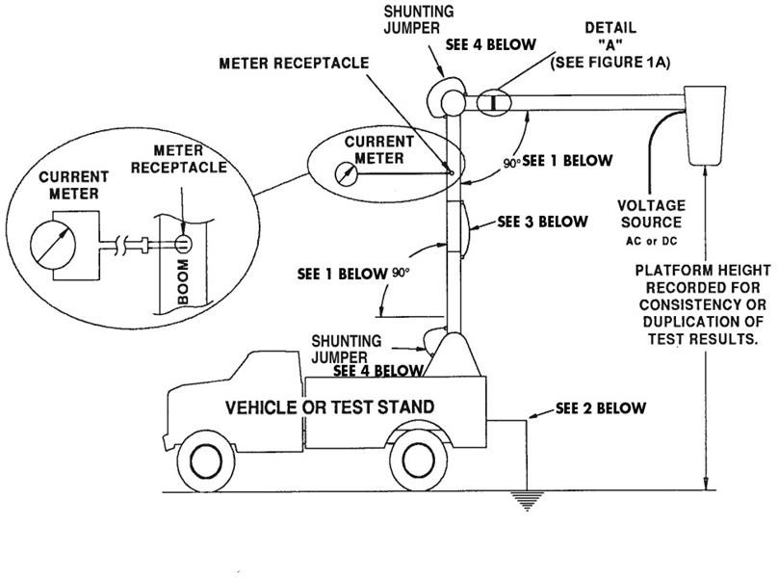
- These boom positions are for outdoor testing. Other positions are acceptable, when indoor testing for example. The positions used for ac tests should be documented and accompany test documents for test repeatability.
- Test stand or vehicle is to be grounded.
- Chassis insulating system shunt (see Figure 3A).
- Electrical continuity over this joint is necessary and may be verified by an ohmmeter or continuity meter. If there is no continuity across the joint, shunting is required.
- Figure 1 shows an example with the meter receptacle above a chassis insulator. Wherever the meter receptacle is located, it shall be tested consistent with the requirements of this standard.

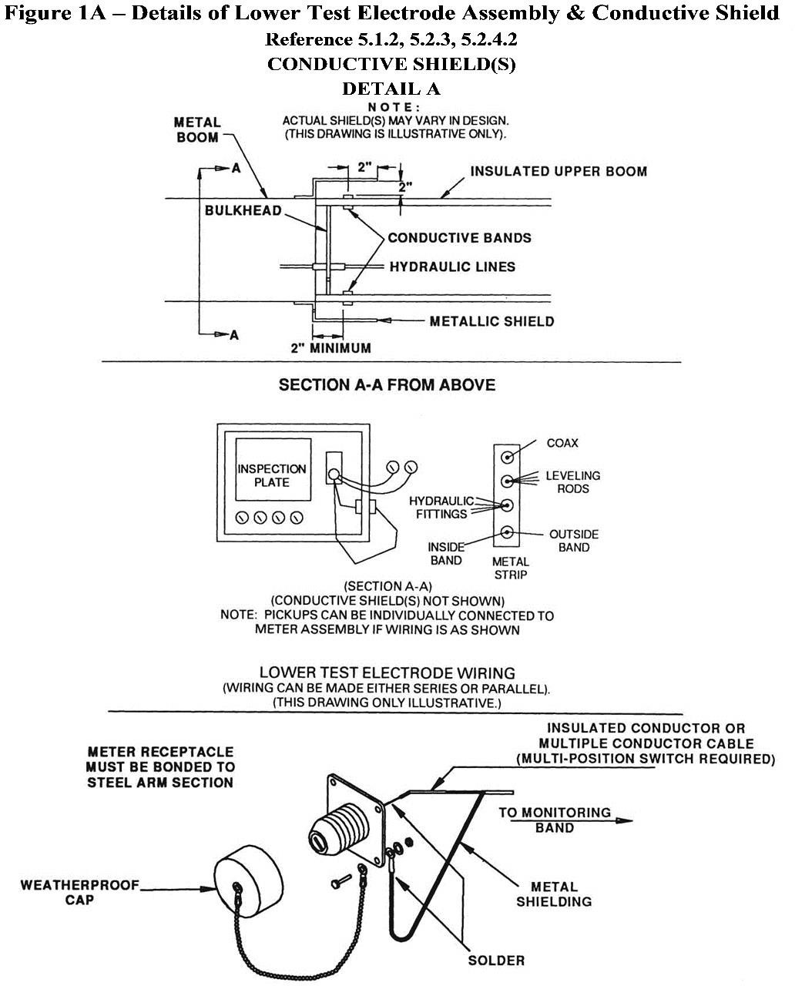

Figure 2 – Dielectric Test Configuration for Category C and D Aerial Devices

(Reference 5.4.2.2 & 5.4.3.2)

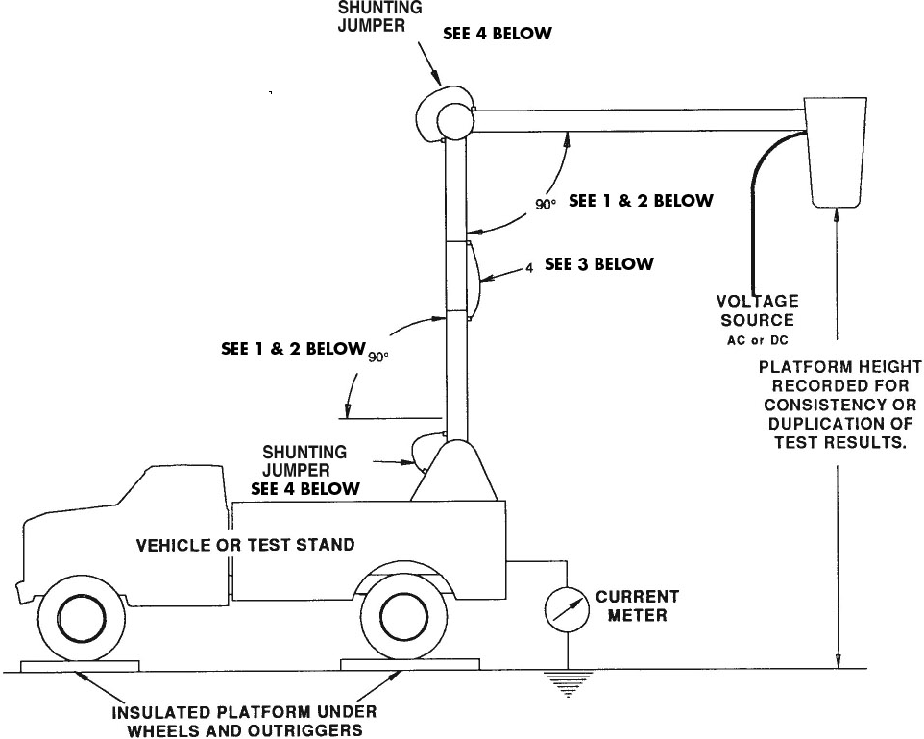

  - Due to ac capacitive currents, these boom angles are more critical than for Category A and Category B aerial devices.
  - These boom positions are for outdoor testing. Other positions are acceptable, when indoor testing for example. The positions used for ac tests should be documented and accompany test documents for test repeatability.
  - Chassis insulating system shunt (see Figure 3A).
  - Electrical continuity over this joint is necessary and may be verified by an ohmmeter or continuity meter. If there is no continuity across the joint, shunting is required.

Figure 2A – Optional Dielectric Test Configuration for Category C and D Aerial Devices

(Reference 5.4.3.2)

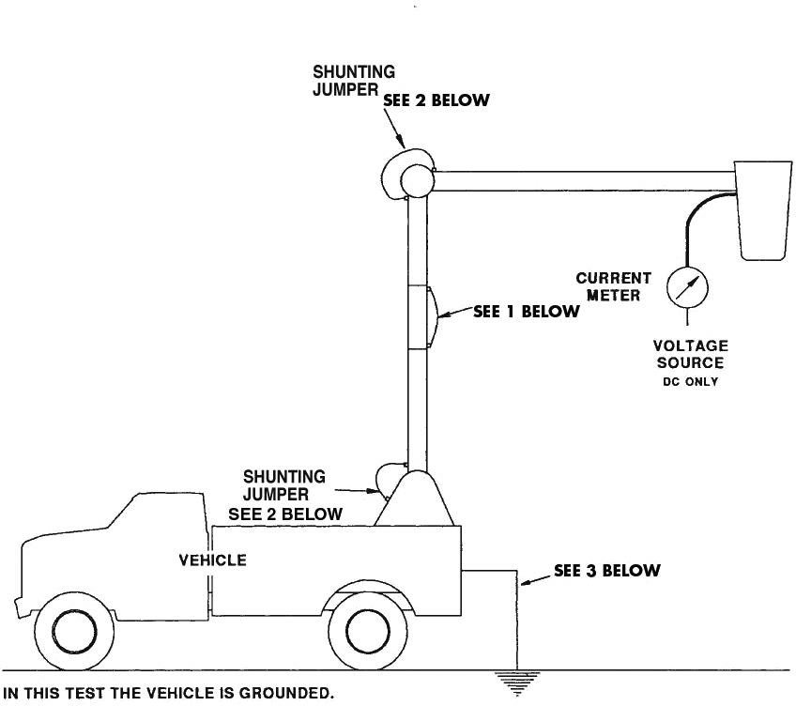

    - Chassis insulating shunt system (see Figure 3A).
    - Electrical continuity over this joint is necessary and may be verified by an ohmmeter or continuity meter. If there is no continuity across the joint, shunting is required.
    - The vehicle is to be grounded.

Figure 3 – Dielectric Test Configuration for Chassis Insulating Systems

(Reference 5.4.2.4 & 5.4.3.4)

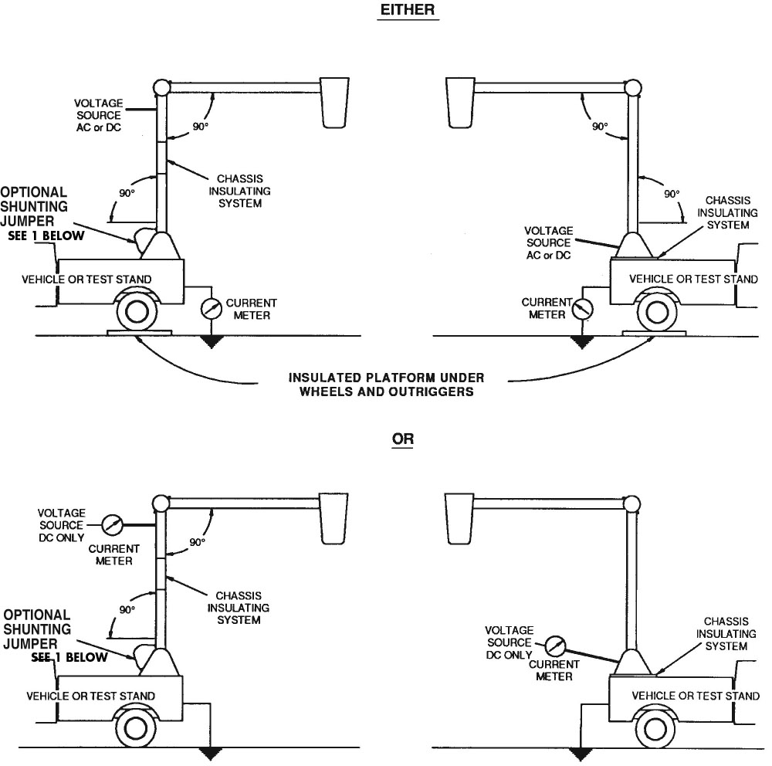

These boom positions are for outdoor testing. Other positions are acceptable, when indoor testing for example. The positions used for ac test should be documented and accompany test documents for test repeatability.

1. Electrical continuity over this joint is necessary and may be verified by an ohmmeter or continuity meter. If there is no continuity across the joint, shunting is required.

Figure 3A – Suggested Shunting Arrangement for Chassis Insulating System

(Reference 5.2.5, 5.4.2.1, 5.4.2.2, 5.4.3.1 & 5.4.3.2)
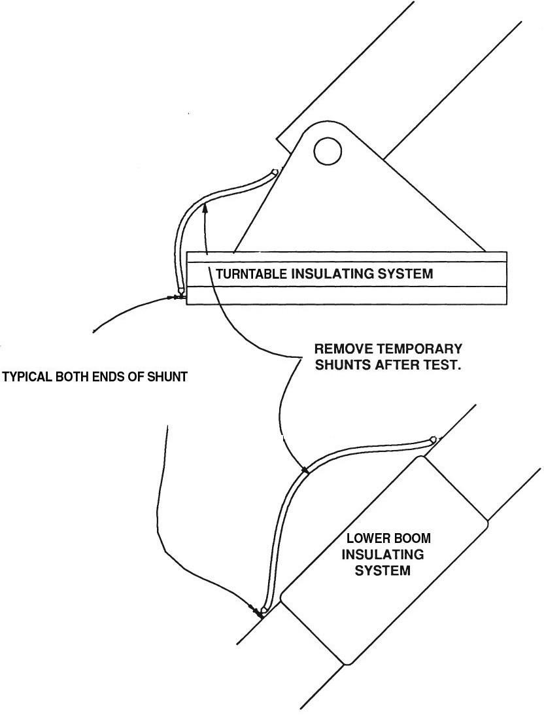

Figure 4 – Boom Positions for Dielectric Test of Extensible Insulating Aerial Devices
(Reference 5.4.2.1, 5.4.2.2, 5.4.3.1 & 5.4.3.2)
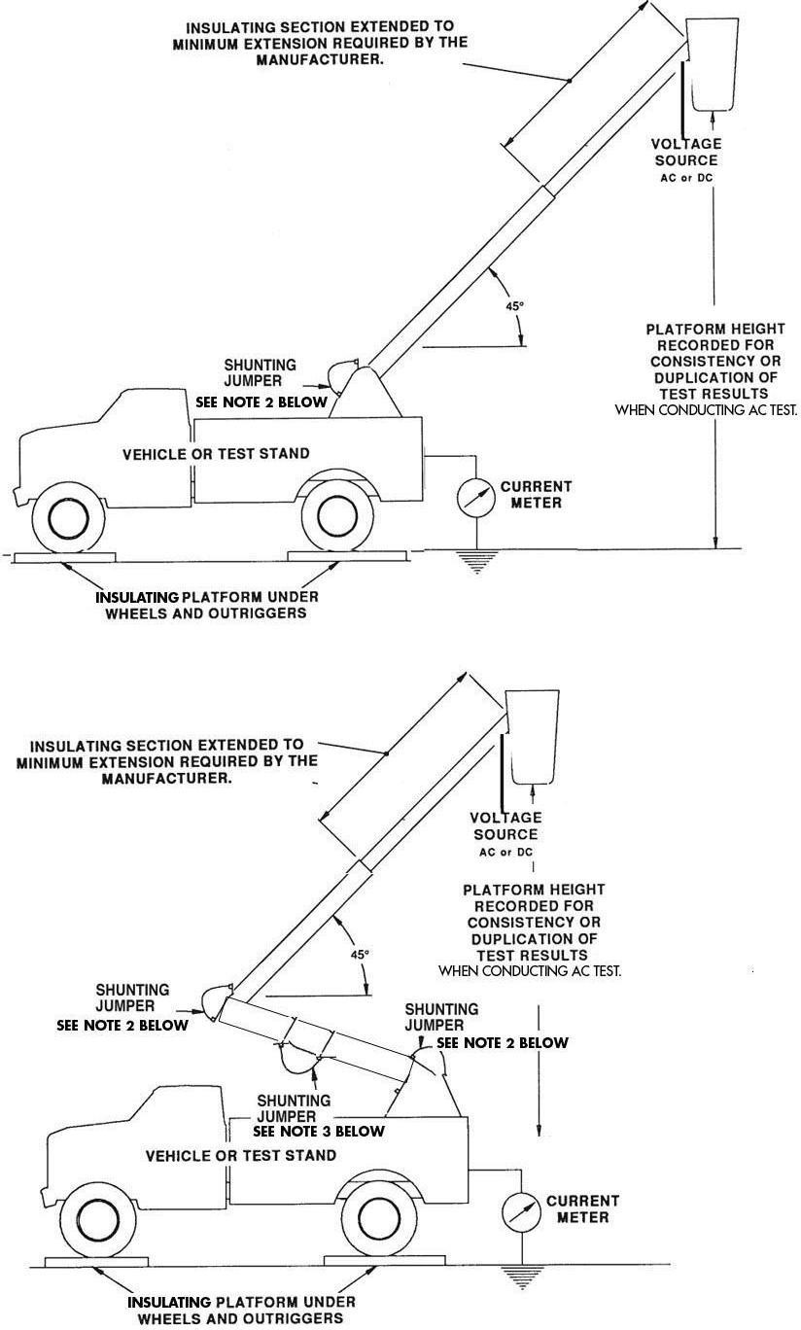

- Due to ac capacitive currents, the boom angle is more critical than for Category A and Category B aerial devices. These boom positions are for outdoor testing. Other boom positions are acceptable, when indoor testing for example. The positions used for ac tests should be documented and accompany the test documents for test repeatability.
- Electrical continuity over this joint is necessary and may be verified by an ohmmeter or continuity meter. If there is no continuity across this joint, shunting is required.
- Chassis insulating system shunt (see Figure 3A).
- An alternative set-up for dc testing may be employed similar to that shown in Figure 2A.

Figure 5 – Typical Bonding Arrangements for Category A, B, C and D Aerial Devices
(Reference 5.1.2; 5.4.2.1; 5.4.2.2; 5.4.3.1 & 5.4.3.2)

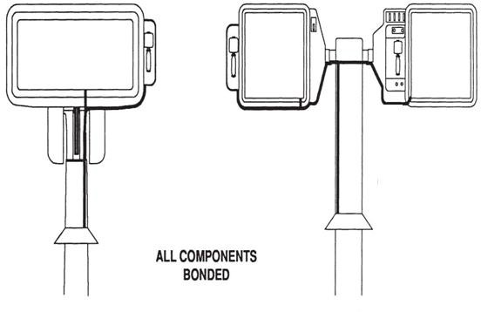

All conductive material at the platform end of the insulating boom must be electrically bonded. (May include bucket mounting hardware, all controls, control valves, tool connections, and gradient control.) May require removing covers.

Figure 6 – Confirmation Test of Upper Control Components with High Electrical Resistance
(when identified as such)
(Reference 5.4.2.6 & 5.4.3.6)
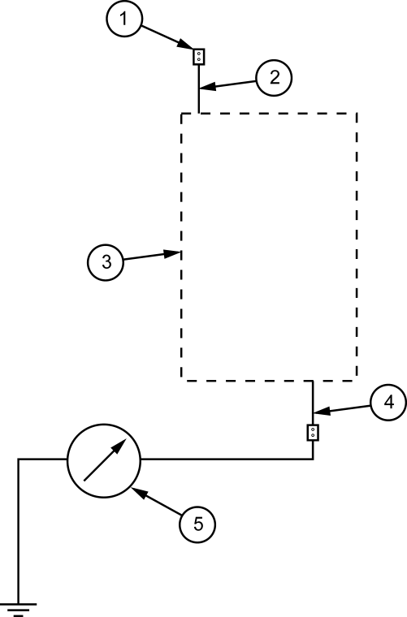

Key

1 | connection to the voltage source | 4 | conductive component at the boom tip side of the high electrical resistance component(s)
2 | operator contact side of the high electrical resistance component(s) | 5 | ammeter
3 | high electric resistance component(s)

Where such controls are provided and identified by the manufacturer for their high electrical resistance properties, they shall be tested at the voltage specified. Figure 6 presents a block diagram of the test set-up and the corresponding diagram of the actual set-up shall be illustrated in the manufacturer’s instructions for use.

Figure 7 – Recommended Identification Plate Format
(Reference 6.5.2)

MAKE OF AERIAL DEVICE MODEL YEAR OF MANUFACTURE SERIAL NO INSULATING or NON-INSULATING RATED PLATFORM HEIGHT CATEGORY CONFIGURED FOR ELECTRICAL WORK RUBBER GLOVING YES NO CHASSIS INSULATING SYSTEM YES NO RATED LOAD CAPACITY:
This Aerial Device Complies with the Requirements of ANSI/SAIA A92.2 and/or CAN/CSA-C225
Unit equipped with platforms

On a firm and level surface, capacity is: lbs. (kg) per bucket or platform Or lbs. (kg) Total (both buckets or platforms)
Date of Test: QUALIFICATION VOLTAGE
Date of Test:
UNIT EQUIPPED WITH UPPER CONTROLS WITH HIGH ELECTRICAL RESISTANCE Yes No UNIT EQUIPPED WITH MATERIAL HANDLING ATTACHMENT Yes No AERIAL DEVICE SYSTEM PRESSURE AERIAL DEVICE CONTROL SYSTEM VOLTAGE AMBIENT TEMPERATURE RANGE FOR WHICH THE AERIAL DEVICE IS DESIGNED AERIAL DEVICE MANUFACTURER
City State/Province Country INSTALLED BY:

The following Appendices (Appendix A-G) are furnished only to provide explanation, clarification, and potential guidance.

APPENDIX A – ELECTRICAL TEST TERMINOLOGY AND CLARIFICATION

- When an aerial device is to be used for ac application, design tests shall be conducted with alternating current. These tests are conducted on the initial unit of a particular design.

- Qualification tests are to be conducted per the appropriate section of Table 1, depending upon the rated voltage of intended use.

- “Wet testing” is a description used for electrical testing after insulating components or insulating aerial devices have had water applied to them. This method is sometimes used in testing the resistivity and conductivity of insulating components, particularly the surface(s) of them. Properly maintained insulating components should not exhibit water absorption. The test values contained in this standard are for dry insulating components.

- The leakage current recorded as part of the Qualification Test is to be provided as part of the test data, and can be used as a benchmark for future testing.

- The term “certified test” is not used. The Qualification Test is the test that is certified as being accurate and applicable to a particular unit.

APPENDIX B – DC APPLICATION When an aerial device is to be used for dc application as a Category A device, the following applies:

 |  |  | Direct Current withstand
Rated Line Voltage | Max* Boom Leakage  Current | Time of Test | Double Rated Line Voltage | Over Voltage Test
“X” kV | 0.5  microamperes  /kV | 3 minutes | “2X”kV | 2X(F) **kV
  - The double voltage and over voltage test are for 1 minute duration.
  - Record leakage current as data for future testing.
* The leakage current should maintain a steady value for at least one minute before the test is concluded.
** F = Switching Factor or Over Voltage Factor.

APPENDIX C – APPLICATION AND USES OF AERIAL DEVICES

Category | Bare-Hand | Gloving4 | Live Line Tool1 (e.g. Hot Stick) | De-Energized
A B C D E  Non-Insulating | X  **2 | X3 X3 X | X X X X X X | X X X X X X

- Aerial Device is used as a work platform. Live line tools of appropriate dielectric ratings are to be depended upon for primary protection.
- An aerial device manufactured as a Category A may be modified and used as a Category B and a Category B may be modified and used as a Category A in accordance with the manufacturer’s instructions. In the event that this is done, particular attention must be given to the appropriate qualification test, gradient control devices, conductive shields, conductive liners, and bonding.
- Category A and B units may be used for gloving if they meet the requirements of Section 4.10 Covers and are configured for the application according to the manufacturer’s instructions
- Per IEEE 516 Guide for Maintenance Methods on Energized Power Lines. The aerial device insulating system is used as secondary protection.

APPENDIX D – ELECTRICAL TESTS FOR AERIAL DEVICES, INSULATED PLATFORMS AND INSULATED LADDERS FOR AC APPLICATION

 | Design | Qualification | Periodic | Field Periodic
Category A & B | Table 1 | Table 1 | Table 2 | Table 3
Category C & D | Table 1 | Table 1 | Table 2 | Table 3
Category E | Table 1 | Table 1 | Table 2
Insulated Ladder | Table 1 | Table 1 | Table 2
and Platform

APPENDIX E – ELECTRICAL TESTS FOR AERIAL DEVICES BUILT IN COMPLIANCE TO EARLIER EDITIONS OF THIS STANDARD.

Previous A92.2 Standards allowed for dielectric ratings at 69kV and below* which do not meet this Edition. Previous testing requirements may be relied upon for those machines. However, use of the applicable tests herein provides confirmation of integrity. To assist users of these devices in application of periodic testing values of this standard, the following table is provided.

Previous A92.2 Standards required Category C devices with a rated platform height greater than 50 feet (15.3 m) with insulating hydraulic lines which cross the insulating portions to have a method to prevent vacuum formation in such lines which would result in the reduction in dielectric strength. Current A92.2 does not have this requirement thus these provisions may be removed per requirements of 8.5 Modifications

Unit Rating | 60 Hertz (rms) Test |  |  | Direct Current Test
69 kV and Below | Voltage (kV) | Maximum Allowable Current  (µA) | Time (Minutes) | Voltage (kV) | Maximum Allowable Current  (µA) | Time (Minutes)
Measured through Lower Electrode  System | 60 | 60 | 1 | 84 | 42 | 3
Measured without  Lower Electrode System | 60 | 600 | 1 | 84 | 84 | 3

* In an attempt to recognize that insulating aerial devices that are used for “gloving” of electrical distribution voltages the rating of aerial devices were changed to “46kV and below” in the 1990 Edition. The change in the rating was also meant to draw a clear distinction between machines rated for distribution voltages and those for the voltage levels of transmission lines.

APPENDIX F—PRECAUTIONS FOR USE OF AERIAL DEVICES ON OR NEAR ENERGIZED APPARATUS

This appendix contains considerations for the determinations of Minimum Approach Distances to energized overhead power facilities for aerial devices and platform occupants and the differing levels of required skill and training corresponding to the differing levels of exposure to the associated hazards.
Minimum Approach Distances are covered by various widely used industry standards and regulations. The most commonly known are OSHA Part 29 CFR Part 1900 and ANSI C2, the National Electrical Safety Code, which has been adopted by many State legislatures. In order to establish meaningful safe approach distances, both the insulation level of the aerial device and the qualification level(s) of the platform occupant(s) must be established.

Definitions
Insulating Aerial Device: An aerial device with dielectric components designed and tested to meet the specific electrical insulating rating consistent with the manufacturer’s identification plate.

Non-insulating Aerial Device: An aerial device having no specific electrical rating. For purposes of determining Minimum Approach Distances, an insulating aerial device that is operating in an environment in which the voltages exceed those assigned to the device is considered non-insulating.

Unqualified Person: A person who does not have approval to approach energized lines and apparatus and has received no significant training regarding the electrical hazards involved in the placing of an aerial device, platform occupants, and their tools closer to energized lines and facilities than the distances listed in Table A below.

Qualified Person (for Purposes of Minimum Approach Distances): A person who has received training, understands and is conversant in the electrical hazards involved in the placing of an aerial device, platform occupants, and their tools closer to energized lines and facilities than the distances listed in Table A below, and has approval to perform the work.

Note: This is an expansion to the “Qualified Person” definition in Section 3. It is designed to include the specialized knowledge required for determination of Minimum Approach Distances.

To be qualified, different levels of training and skill are required depending upon the work to be accomplished and the electrical hazards associated with that work. Qualification levels range from the person unqualified to work on utility lines and associated facilities, yet who is subjected to significant risk of injury from electrical hazards in the performance of their work, to the level of a person who is qualified to work on, and in close proximity, to power utility lines and associated facilities.
Qualified persons shall be trained and skilled in knowing the dangers involved and the methods to avoid them. Training shall be under the supervision of a person or persons qualified at that specific level or higher. It shall be clear that the term “qualified” represents different levels of training and skill.

An example of work requiring a lesser amount of training is an aerial device operator and/or platform occupant performing maintenance on a building without any work objective relative to the energized conductors attached to the building. Training, however, is required for this aerial device operator and platform occupant(s) to know how to address those conductors.

Note: Person(s) with the above lesser amount of training (and the aerial device and tools) can approach closer than the distances listed in applicable standards provided the energized conductors and associated facilities are guarded or covered with appropriate protective equipment. Such protective equipment shall be installed only by person(s) who has been qualified to do so. An example of work requiring a high level of training and skill is the person qualified to work on, and in close proximity, to power utility lines and associated facilities. Minimum Approach Distances for utility linemen are published and reviewed continually by the National Electrical Safety Code committees. They are found in the most recent edition of the Code in Part 4, Rules for Employees and in Part 29 CFR 1910.269, but they can be increased by the State or administrative authority having jurisdiction.

Training of Qualified Person(s) is the responsibility of the employer or his designated contractor(s) and can be classroom, hands-on or a combination, as deemed appropriate by the employer for the degree of risk involved.

An unqualified person, as an operator, shall not approach energized conductors or facilities that will place the insulating or non-insulating aerial device, the operator and other platform occupants, and their tools, closer to such facilities that the distances shown in Table A.

A qualified communications person, as an operator, shall not approach energized conductors or facilities that will place the insulating or non-insulating aerial device, the operator and other platform occupants, and their tools, closer to such facilities than the distances set forth in Part 29 CFR 1910.268 and the National Electrical Safety Code.

A qualified line clearance tree trimmer, as an operator, shall not approach energized conductors or facilities that will place the insulating or non-insulating aerial device, the operator and other occupants, and their tools, closer to such facilities than the distances set forth in Part 29 CFR 1910.268, 1910.269, or ANSI/ISA Z133.1.

A qualified lineman, as an operator, shall not approach energized conductors or facilities that will place the insulating or non-insulating aerial device, the operator and other platform occupants, and their tools, closer to such facilities than the distances set forth in Part 29 CFR 1910.269 and the National Electrical Safety Code. Higher levels of qualifications are required for electrical linemen to physically contact energized conductors and facilities from Category A, B, and C aerial devices.

Table A
Voltage | Minimum Approach Distance
Up to 50 kV Above 50 kV | 10 feet  10 feet plus 4 inches for every 10 kV over 50 kV
Exception: For an aerial device in transit with the lift stowed, the clearance can be reduced to 4 feet for voltages of up to 50 kV. If the voltage is higher than 50 kV, the clearance shall be increased 4 inches for every 10 kV over that voltage.
Ref: OSHA Part 29 CFR 1910.333(c)(3)(iii)(A)(1)

The following standards contain tables and information that govern Minimum Approach Distances to energized overhead power facilities for users and operators of aerial devices:
Part 29 CFR 1910.333 Selection and use of work practices Part 29 CFR 1910.268 Telecommunications
Part 29 CFR 1910.269 Electric Power Generation, Transmissions and Distribution Part 29 CFR 1926.950 Power Transmission and Distribution
ANSI/IEEE C2 National Electrical Safety Code, Part 4, Rules for the Operation of Electric Supply and Communications Lines and Equipment
ANSI/ISA Z133.1 Tree Care Operations – Safety Requirements

It is imperative that users and operators of aerial devices be familiar with the standard(s) pertinent to the type of work being performed.

Handling Energized Apparatus

When the boom tip jib and/or winch of a category B or C aerial device is used for handling energized conductors and apparatus, the energized conductors and apparatus shall be insulated from the boom tip with electrical protection devices that are rated, tested, and maintained for the appropriate rated line voltage. Boom tip jibs used in material handling on aerial devices shall be considered non-insulating unless the jib has been rated, tested, and maintained for the appropriate line voltage. Safety rules and work practices may vary significantly for different users, but one universal rule that applies is when jibs are used as a live-line tool with category B and C aerial devices, platform occupants(s) must use protective equipment such as gloves and cover-ups. If the winch line is used to lift energized apparatus, the energized apparatus shall be insulated from the jib tip with electrical protection devices that are rated, tested, and maintained for the appropriate line voltage. The winch line shall not be considered as insulating. For multi-phase lifting with conductor holders and a cross-arm, phase to phase protection shall be accomplished with a cross-arm that is rated, tested, and maintained for appropriate line voltage.

Live-line tools and jibs shall be used in agreement with manufacturer’s recommendations. Hooks used to lift loads must have a safety latch. A visual inspection must be performed periodically on all tools, winch lines, hooks, and jibs used in live-line working to ensure structural integrity.

Minimum Approach Distances shall be maintained by the electrical worker to assure clearances between objects at different electrical potentials when performing live-line work. This applies to the worker’s reach including any non-insulating object above the insulated section of the aerial device. The Minimum Approach Distance may be obtained from sources such as but not limited to:
ANSI C-2 National Electrical Safety Code ANSI C-1 National Electrical Code
Part 29 CFR 1926.950
Part 29 CFR 1910.269
Work practices

Protective Equipment

This subject varies widely depending upon employer safety rules; hence its use should be governed by company work rules and safety practices (example: glove and cover-up). Such practices are predicated

upon OHSA, ANSI C2, and recognized industry practice, such as but not limited to: Part 29 CFR 1910.335 Safeguards for Personnel Protection
IEEE Std. 516-1995 Guide for Maintenance Methods on Energized Power Lines

Insulating Liners and Insulating Work Platforms

A dielectrically tested insulating liner or insulating work platform is intended to prevent electrical current flow through the lower extremities of the work platform occupant. This is one element in a system approach that includes both work practices and materials designed to avoid electrical contact. Such a liner or work platform shall not be considered primary insulation.

Ground Persons

An aerial device in close proximity (or contact) with an energized conductor can result in current flow that energizes the vehicle. Such an occurrence results in a potentially hazardous condition for all ground personnel who can contact the vehicle or any conductive object attached to it, such as a trailer. In some instances, ground gradients (step potentials) can be elevated to a dangerous level for those near, but not necessarily contacting, the vehicle or its attachments.

Rules covering protection of ground persons can be obtained from sources such as but not limited to: Part 29 CFR 1910.333
ANSI C-2 National Electrical Safety Code ANSI C-1 National Electrical Code
Part 29 CFR 1926.950
Part 29 CFR 1910.269
Work Practices

APPENDIX G – RECOMMENDED IDENTIFICATION AND INSTRUCTION SYMBOLS FOR CONTROL FUNCTIONS

The manufacturers of aerial devices complying with this standard have provided the following symbols and wording as suggested identification and instructional guides for aerial device controls.
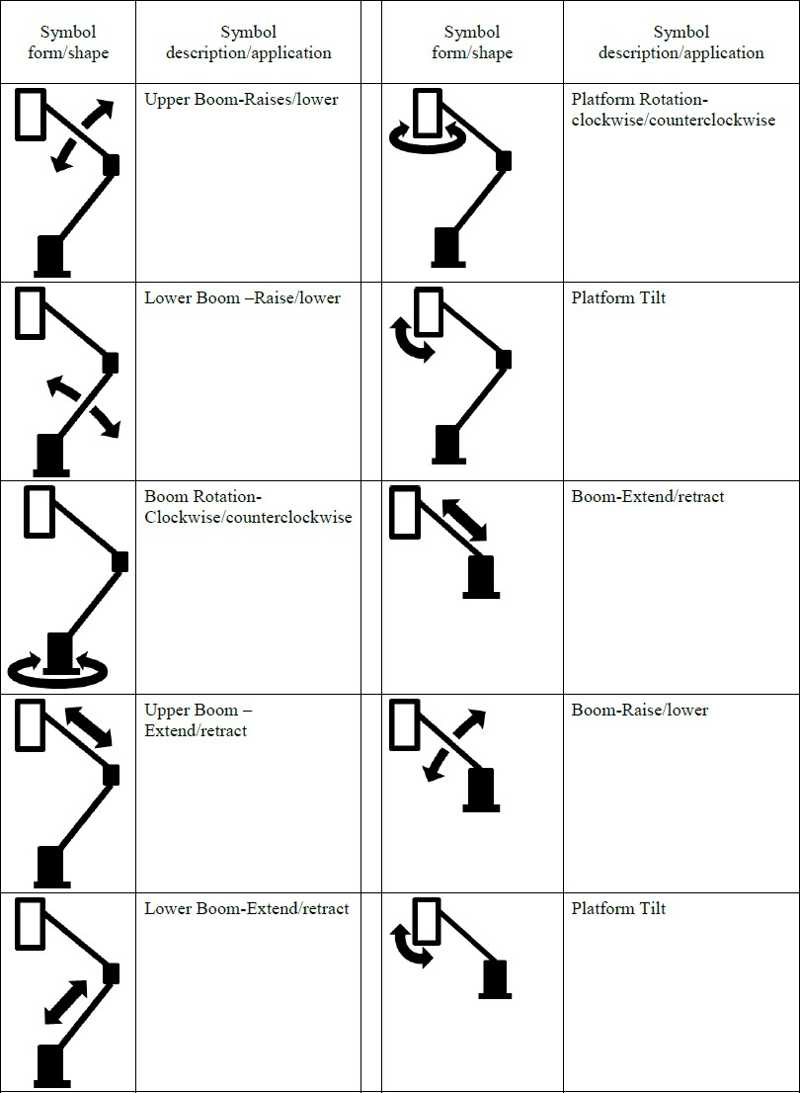

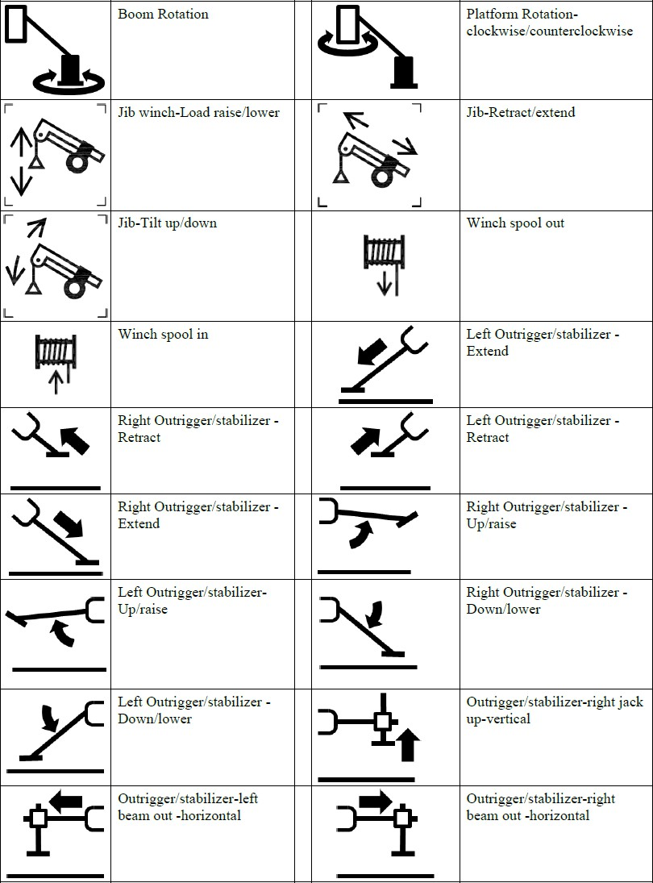

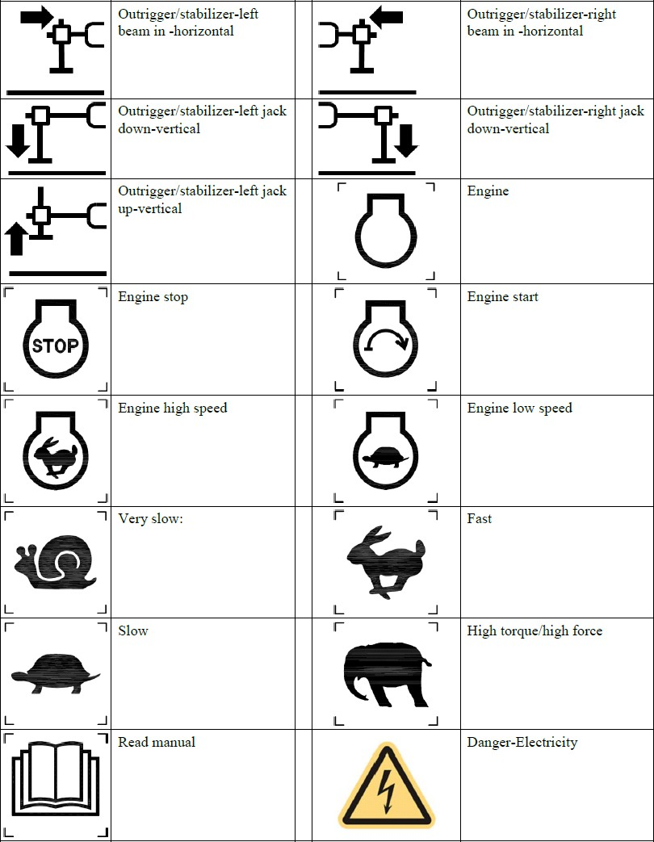

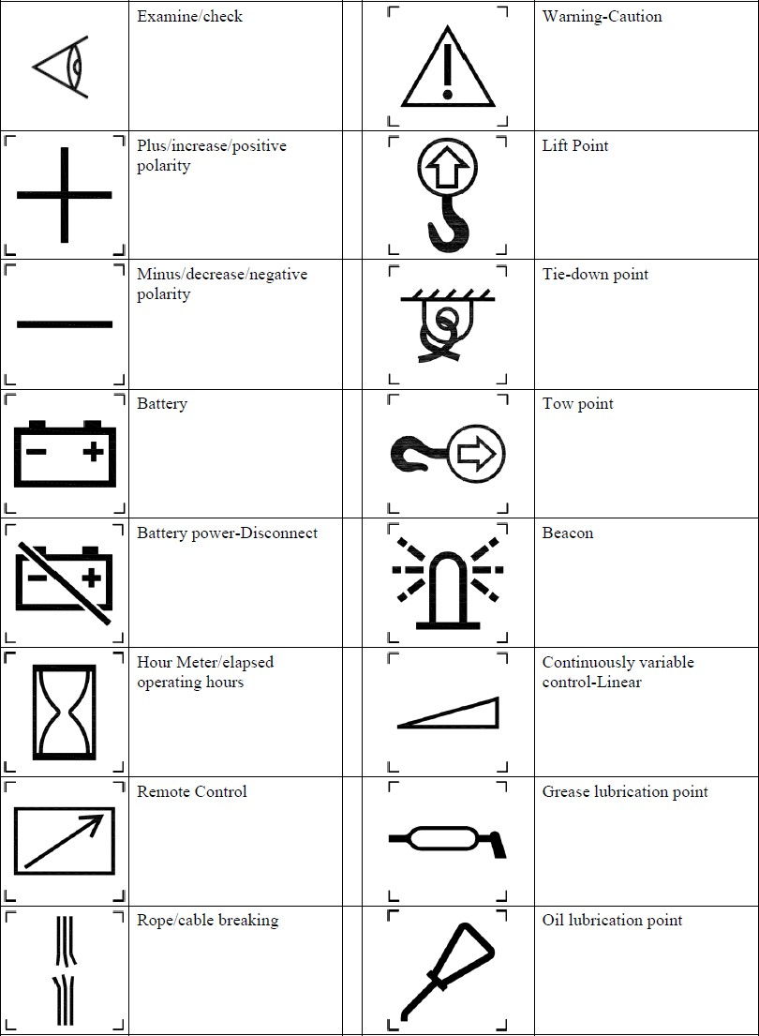

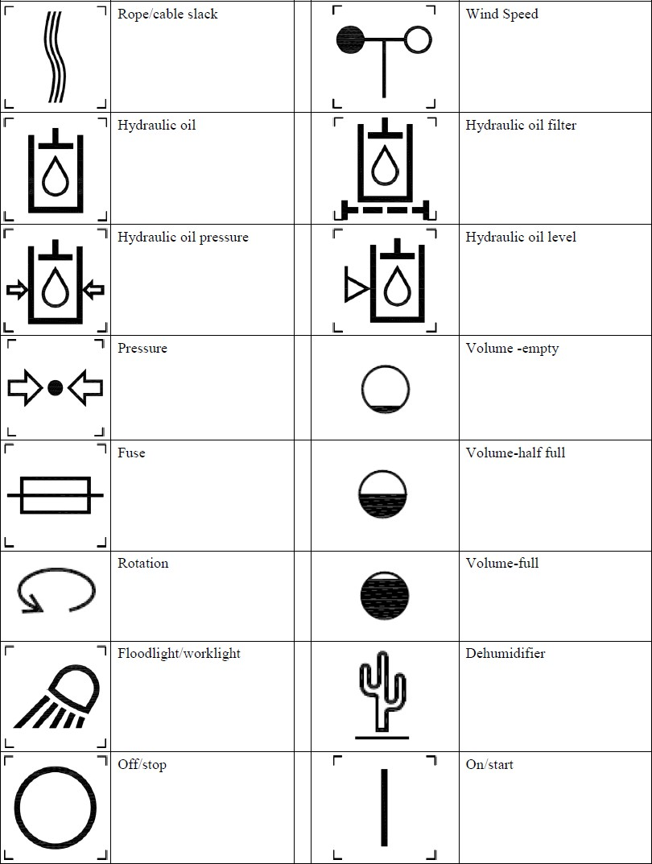

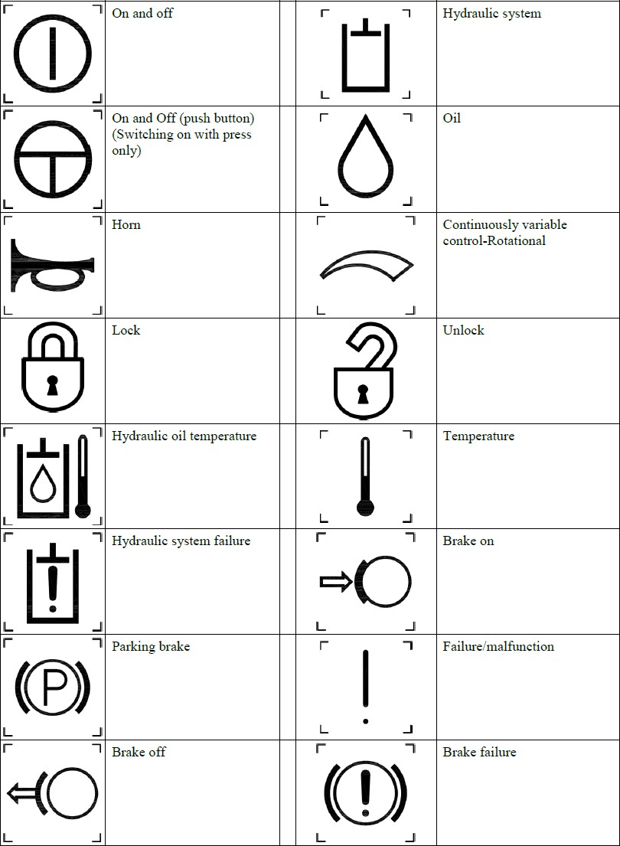

Appendix H
Example Lower Test Electrode System Continuity Check Guide See requirements in sections 5.4.2.1 (3), 5.4.3.1 (4) and Figure 1A

Row | Connection | UHF | BNC | 7-Pin
1 | Inner Conductor -  Outer Conductor | Open | Open | --
2 | Inner Conductor -  Pickup Electrode | Short | Short | --
3 | Outer Conductor - Conductive Shield | Short | Short | --
4 | Pairs A/B | -- | -- | Short
5 | Pins A/B to C/D | -- | -- | Open
6 | Pins A/B to E/F | -- | -- | Open
7 | Pins A/B to G | -- | -- | Open
8 | Pairs C/D | -- | -- | Short
9 | Pins C/D to E/F | -- | -- | Open
10 | Pins C/D to G | -- | -- | Open
11 | Pairs E/F | -- | -- | Short
12 | Pins E/F to G | -- | -- | Open
13 | Pin G to Turret  Ground | -- | -- | Open

70
© 2021 SAIA – All Rights Reserved

American National Standards for Aerial Work Platforms

ANSI/SAIA A92.2 Vehicle-Mounted Elevating and Rotating Aerial Devices ANSI/SAIA A92.7 Airline Ground Support Vehicle-Mounted Vertical Lift Devices ANSI/SIA A92.9 Mast-Climbing Work Platforms
ANSI/SAIA A92.10 Transport Platforms
ANSI/SAIA A92.20 Design, Calculations, Safety Requirements and Test Methods for Mobile Elevating Work Platforms (MEWPs)
ANSI/SAIA A92.22 Safe Use of Mobile Elevating Work Platforms (MEWPs) ANSI/SAIA A92.24 Training Requirements for the Use, Operation, Inspection, Testing and Maintenance of Mobile Elevating Work Platforms (MEWPs)

ANSI/SAIA A92 Standards are under continual development. Contact the Scaffold & Access Industry Association for the current updated information.

Scaffold & Access Industry Association, Inc. 400 Admiral Boulevard
Kansas City, MO 64106 Phone: 816-595-4860
Fax: 816-472-7765
Email: info@scaffold.org Web: www.saiaonline.org

71



400 Admiral Blvd., Kansas City, MO 64106 816.595.4860
info@saiaonline.org

